Final Project Report
Book Recommendation Platform
Lakshmi Narayana Manukonda
Professional Seminar
COMP-669-B.FA25
Prof. David Pitts & Prof. Vladimir Riabov
Rivier University
December 8th, 2025

1. Executive Summary
Readers today face an overwhelming number of book choices, often stored in large spreadsheets or online catalogs that are difficult and time-consuming to navigate. This project addresses that problem by developing a Python-based desktop Book Recommendation Platform that helps users quickly discover, filter, and organize books that match their interests. Built with Tkinter, the application loads an enriched CSV/XLSX dataset and provides intuitive search filters for title, author, language, genre, and difficulty, reducing the effort required to find suitable books. On top of basic search, the system uses a TF-IDF and cosine similarity recommendation engine (implemented with pandas and scikit-learn) to suggest books similar to a favorite title, aligned with preferred authors/genres, or related to a specific topic, turning a large, static dataset into a dynamic discovery tool.
The platform also supports ongoing reading management and progress tracking. Users can add books from the results table to To-Read and Completed lists, which are persisted in a local JSON state file so their reading history survives across sessions. A dashboard tab, built with matplotlib, visualizes To-Read vs Completed counts to give a quick snapshot of engagement. Architecturally, the system separates concerns into a BookApp controller for the UI, a BookData class for dataset loading, filtering, and recommendations, and small utilities for state management and reusable UI components. This layered design, supported by use case, class, sequence, state-chart, ER, and deployment diagrams, makes the application easier to maintain, extend to new datasets, and enhance with additional recommendation strategies in the future.

2. Table of Contents
1. Executive Summary............................................................................................................….....2
2. Table of Contents……………………………………………………………………………….3
3. Introduction……………………………………………………………………………………..4
4. Project Plan........................................ ................................................................. ……………...5
5. Functional Specifications....................................................................................................…...10
5.1 Actors/Roles.......................................................................................................……..10
5.2 Business Rules..............................................................................................................10
5.3 Use-Case diagram………………………………………….........................................12
5.4 Use-Case descriptions………………………………………………………………..13
5.5 Class Diagram..................................................................................................……....24
5.6 Object Diagram............................................................................................……...….24
5.7 Sequence Diagram…………………………………………………………………...25
5.8 State Chart Diagram............................................................................................…….26
6. Functional Tests Plan.................................................................................................................27
7. System Design Specifications......................................................................................…...…...31
7.1 Deployment Diagram.................................................................................………......31
7.2 Package Diagram……………………………………………………………………..32
7.3 Database Tables……………………………………………………………………....33
7.4 Entity - Relational Diagrams………………………………………………………....35
7.5 Window Navigation Diagrams…………………………………………………….....36
7.6 Drafts of User Interfaces……………………………………………………………...37
8. Integration Tests Plan………………………………………………………………………….38
9. Programming environment and tools………………………………………………………......41
10. Unit/Modules Test Plan……………………………………………………………………....42
11. Results of Unit/Modules Tests, Integration Tests and Functional Tests……………………..48
12. Demo…………………………………………………………………………………………51
13. Issues to Future Studies........................................................………………………………....60
14. Conclusion...........................................................…………………………………………….61
15. References................................................................................ ……………………………...62
16. Appendix……………………………………………………………………………………..62
16.1 Main Code…..………………………………………………………………………62
16.2 Unit and Module Tests………………………………………………………………78
16.3 Integration Tests….…………………………………………………………………83
16.4 Functional Tests….…………………………………………………………………87

3. Introduction
The Book Recommendation Platform is a Python-based desktop application designed to help readers choose their next book more easily from large and often overwhelming book lists. Instead of manually scanning through spreadsheets or online catalogs, the user can load an enriched CSV or Excel dataset of books and explore it through a clean Tkinter interface. The system lets users filter by title, author, language, genre, and difficulty so they can quickly narrow down options that match their preferences. Beyond simple filtering, it uses a TF-IDF and cosine similarity–based recommendation engine (built with pandas and scikit-learn) to suggest books similar to a favorite title, aligned with preferred authors and genres, or related to a keyword or topic. The application also supports basic reading management: users can add books to To-Read and Completed lists, which are saved in a local JSON file so progress persists between sessions. A dashboard tab, implemented with matplotlib, provides a visual summary of the user’s reading progress by comparing the number of To-Read and Completed books. Overall, the project combines graphical user interface design, data processing, and information retrieval techniques to deliver a practical, user-friendly book discovery tool.

4. Project Plan
4.1 Goal
Build a standalone Python desktop Book Recommendation Platform that helps readers quickly discover, filter, and track books from a large local dataset. The system will provide a Tkinter-based GUI, use a TF-IDF + cosine similarity engine (pandas + scikit-learn) for intelligent recommendations, and store reading lists and app state in local JSON files so everything works offline once the dataset is available.

4.2 Objectives
- Smart Book Discovery:
Use TF-IDF and cosine similarity over an enriched CSV/XLSX dataset to recommend books based on preferred authors, genres, favorite titles, or keyword topics.
- Powerful Search & Filters:
Provide search by title, author, language, genre, and difficulty, with a sortable results table to help users quickly narrow down to relevant books.
- Reading List Management & Persistence:
Allow users to maintain To-Read and Completed lists and save them to a JSON “AppState” file so their progress is preserved across sessions.
- Progress Visualization:
Offer a dashboard tab using matplotlib to display a simple bar chart of To-Read vs Completed counts, giving a quick view of reading progress.
- Extensible Architecture:
Separate UI, data/model, and persistence logic (e.g., BookApp, BookData, state utilities) so that new recommendation strategies or datasets can be added without major refactoring.

4.3 Scope
In-Scope
- Loading an enriched books dataset from CSV/XLSX via a configurable DATASET_PATH.
- Automatic and manual mapping of dataset columns (title, authors, genres, language, description, rating, difficulty).
- Search functionality with filters for:
  - Title contains, Author contains
  - Language, Genre, Difficulty
  - Max results to show
- Recommendation features:
  - Personalize (preferred authors/genres profile)
  - Recommend by Title
  - Recommend by Keyword/Topic
- Management of reading lists:
  - Add selected books from Results to To-Read
  - Mark selected as Completed
  - Remove items from To-Read and Completed
- Local JSON persistence of:
  - To-Read list
  - Completed list
  - Any additional simple app state
- Dashboard tab with matplotlib bar chart (To-Read vs Completed).
Out-of-Scope
- Web or mobile versions of the platform.
- Cloud databases or remote backends (only local CSV/XLSX + JSON files).
- User authentication or multi-user account management.
- Integration with external book APIs (e.g., Goodreads, Google Books APIs) for this version.
- Advanced ML techniques (deep learning, collaborative filtering, etc.) beyond TF-IDF + cosine similarity.

4.4 Deliverables
- Design Documentation
  - Use case diagram, class diagram, object diagram, sequence diagram, state-chart, ER diagram, and deployment diagram for the application.
- Working Desktop Application
  - Tkinter-based GUI (BookApp) integrated with BookData and state utilities, supporting search, recommendation, reading list management, and dashboard.
- Source Code & Configuration
  - Python source files (BookApp, BookData, helpers) and configuration constants (e.g., DATASET_PATH, APP_STATE_PATH).
- Test Artifacts
  - Unit tests (where feasible) for core logic such as filtering and recommendation functions.
  - Integration test descriptions connecting GUI actions to backend methods.
- User Guide / README
  - Installation and run instructions (Python version, required libraries such as pandas, scikit-learn, matplotlib, Tkinter).
  - Steps on how to load a dataset, perform searches, generate recommendations, manage lists, and use the dashboard.
- Final Project Report & Slide Deck
  - Written report summarizing motivation, design, implementation, and evaluation.
  - Presentation slides including diagrams, UI screenshots, and a brief demo flow.

4.5 Methodology & Phases
Phase | Key Activities
1. Requirements & Planning | Define main user tasks (search, recommend, manage lists, view progress). Write user stories and acceptance criteria. Identify dataset format and required columns. Decide on TF-IDF configuration and JSON state structure.
2. Architecture & Design | Create UML diagrams (use case, class, sequence, state-chart, ER, deployment). Decide responsibilities of BookApp, BookData, ScrollableFrame, and state utilities. Plan package structure for UI, data, and utilities.
3. Data & Recommendation Layer | Implement BookData to load CSV/XLSX, map columns, normalize genres and languages, and build the TF-IDF matrix. Implement search and recommendation methods (profile-based, similar title, keyword-based). Validate results with small tests.
4. GUI Development | Build the main Tkinter window (BookApp), menus, scrollable left sidebar (filters, personalize, title/keyword sections), and right-side tabs (Results, To-Read, Completed, Dashboard). Connect GUI events (buttons, comboboxes) to data methods.
5. State & Dashboard Integration | Implement JSON-based state loading/saving for To-Read and Completed lists. Implement list refresh logic and the matplotlib-based dashboard that updates after list changes and search/recommendation actions.
6. Testing & Refinement | Manually test workflows: auto-load dataset, manual load, search with filters, all three recommendation modes, list management, and dashboard refresh. Fix bugs, refine the column mapping dialog, and ensure graceful error handling for missing or invalid datasets.
7. Documentation & Packaging | Finalize code comments, README, and user instructions. Capture UI screenshots for the report and slides. Optionally experiment with packaging (e.g., PyInstaller) for a single-file executable, if time permits.

4.6 Timeline & Milestones
Here’s a 10-week breakdown:
- Week 1:
Finalize problem statement, goals, and detailed requirements. Identify the enriched books dataset and confirm needed columns.
- Week 2:
Draft UML diagrams (use case, class, object, sequence, state-chart, ER, deployment). Plan BookApp and BookData interfaces.
- Week 3:
Implement BookData.load_file() and set_column_map(). Normalize genres/languages and build the TF-IDF text field. Test basic dataset loading.
- Week 4:
Implement search filtering (search() and _apply_filters()). Validate that filters for title, author, language, genre, and difficulty work as expected.
- Week 5:
Implement recommendation methods: recommend_for_profile(), recommend_like_title(), and recommend_by_keyword(). Test similarity results on sample queries.
- Week 6:
Build the Tkinter layout: menus, scrollable sidebar, Results tab with Treeview. Wire Search and Clear Filters to backend methods.
- Week 7:
Add To-Read and Completed tabs, list management functions, and JSON state utilities (load_state, save_state, persist_lists, refresh_lists).
- Week 8:
Implement the Dashboard tab with matplotlib bar chart and integrate refresh_dashboard() into all relevant workflows. Improve user messages and error handling.
- Week 9:
Perform end-to-end testing: dataset auto-load, manual mappings, search, all recommendation flows, list operations, and dashboard updates. Fix defects and polish UI.
- Week 10:
Finalize documentation (README, user guide, project report sections, and diagrams). Prepare and refine presentation slides and demo scenario.

4.7 Roles & Responsibilities
Since you are effectively doing everything, you can still describe the work in terms of roles:
- Project Lead / Developer
  - Define requirements and scope.
  - Implement BookData, BookApp, and supporting utilities.
  - Integrate TF-IDF, search, recommendations, and JSON persistence.
- UI Designer
  - Design and refine the Tkinter layout (sidebar + tabs).
  - Ensure the interface is readable and easy to use.
- Tester / QA
  - Create test scenarios for search, recommendations, and list management.
  - Perform manual end-to-end tests and track/fix bugs.
- Technical Writer
  - Write README, user instructions, and final project report sections.
  - Prepare presentation slides explaining design and features.

4.8 Resources & Tools
- Languages & Frameworks:
  - Python 3.x
  - Tkinter for GUI
- Libraries:
  - pandas for data loading and manipulation
  - scikit-learn (TF-IDF and cosine similarity)
  - matplotlib for dashboard charting
  - json, os, re, and tkinter.ttk from the standard library
- Version Control:
  - Git and GitHub (for code, issues, and documentation)
- Development Environment:
  - Windows laptop/PC with Python 3.x and virtual environment support
  - Any text editor or IDE (VS Code, PyCharm, etc.)
- Project Management:
  - Simple task lists, Trello/Jira, or a manual checklist for tracking phases and tasks.

4.9 Risk Management
- Incorrect or Missing Column Mappings
  - Risk: Dataset may use different column names (e.g., original_title instead of title).
  - Mitigation: Provide both automatic guesses and a manual mapping dialog; show clear error messages when required columns are not mapped.
- Large Dataset Performance
  - Risk: TF-IDF fitting and similarity calculations may be slow on very large datasets.
  - Mitigation: Limit max_features in TfidfVectorizer, cap “Max results to show,” and test performance on typical dataset sizes.
- State File Corruption (JSON)
  - Risk: Unexpected shutdown could corrupt the JSON state file.
  - Mitigation: Use simple, robust writes (overwrite fully) and handle JSON decode errors by falling back to empty state with a warning.
- Poor Recommendation Quality
  - Risk: TF-IDF similarity may sometimes produce irrelevant suggestions.
  - Mitigation: Combine filters (language/genre/difficulty) with similarity scores; allow the user to refine results with additional keywords or different titles.
- Usability Issues in GUI
  - Risk: Users may not understand how to move from Results to To-Read/Completed or when to refresh the dashboard.
  - Mitigation: Add labels/tooltips, confirmation messages, and a short guide in the README describing the main workflow.

5. Functional Specifications
The functional specifications of the project are explained in detail in the following sections:

5.1 Description of Actors/Roles
User
- A person who interacts with the Book Recommendation Platform through the desktop GUI.
- Can search for books using filters (title, author, language, genre, difficulty) and clear filters/results as needed.
- Can personalize a basic “profile” by entering preferred authors and genres and then request recommendations.
- Can request recommendations by typing a favorite title or a keyword/topic.
- Can select rows in the results grid and manage reading lists by adding items to To-Read, marking items as Completed, and removing items from either list.
- Can refresh the dashboard to view an updated progress chart based on current To-Read and Completed lists.

5.2 Business Rules
5.2.1 Search and Filter Rules
- The Search books use case always applies the current Set filters (title, author, language, genre, difficulty, max results).
- If no filters are provided, Search returns the full dataset up to the configured maximum number of results.
- The Clear filters use case resets all filter fields to their default values (e.g., “Any” for language/genre/difficulty and empty text for title/author).
- The Clear results use case removes all rows from the results grid without changing any filter values.
- Filtered search results must be displayed in a tabular form that includes at least: title, authors, language, and, when available, rating and difficulty.
5.2.2 Selection Rules
- The Select row in results use case is a precondition for all list-management actions (Add selected to To-Read, Mark selected as completed).
- If no row is selected when a list-management action is triggered, the system must not change any reading lists.
5.2.3 Recommendation Rules
- Personalize profile collects preferred authors and/or genres from the user; Get recommendations uses this profile together with current filters to generate a ranked list of books.
- Recommend by title uses a user-supplied book title as the main similarity anchor and returns other books that are considered similar; the original title should not reappear in the recommendation list.
- Recommend by keyword uses a free-text keyword or topic (e.g., “investing”, “magic school”) to find books whose textual features best match the query.
- All recommendation use cases must respect active filters (language, genre, difficulty, and optional title/author keywords) and must return at most the configured maximum number of results.
- Recommendation results are shown in the same results grid as regular search, including an optional similarity score column when available.
5.2.4 Reading List Management Rules
- Add selected to To-Read adds selected titles from the results grid to the To-Read list.
  - A title may appear at most once across To-Read and Completed; duplicates must be prevented.
- Mark selected as completed moves or adds selected titles to the Completed list:
  - If a title exists in To-Read, it should be removed from To-Read before being added to Completed.
  - If a title is already in Completed, it must not be added again.
- Remove from To-Read deletes the selected item(s) from the To-Read list only; it must not affect Completed.
- Remove from completed deletes the selected item(s) from the Completed list only; it must not affect To-Read.
- After any list-management operation, the on-screen To-Read and Completed views must be refreshed to reflect the current state.
5.2.5 Persistence Rules
- The Persist lists use case is included by all operations that modify To-Read or Completed (Add selected to To-Read, Mark selected as completed, Remove from To-Read, Remove from completed).
- Persist lists must save the current To-Read and Completed lists to a local state file (e.g., JSON) without requiring extra user action.
- When the application starts, it must attempt to reload existing lists from the state file; if the file is missing or unreadable, the system starts with empty lists and continues normally.
5.2.6 Dashboard & Progress Chart Rules
- The Refresh dashboard use case triggers recomputation of summary values (counts of To-Read and Completed) and updates the View progress chart included use case.
- The progress chart must display, at minimum, the total number of To-Read and Completed items.
- If both lists are empty, the dashboard should indicate that no data is available yet (e.g., explanatory message instead of a bar chart).

5.3 Use-Case Diagram
The use case diagram (Figure 5.3.1) for the Book Recommendation Platform shows how the single User interacts with the system at a high level. It summarizes all major functions—searching with filters, requesting different types of recommendations, managing To-Read and Completed lists, and viewing the progress dashboard—and highlights the common Set filters, Persist lists, and View progress chart behaviors that are shared across multiple use cases.
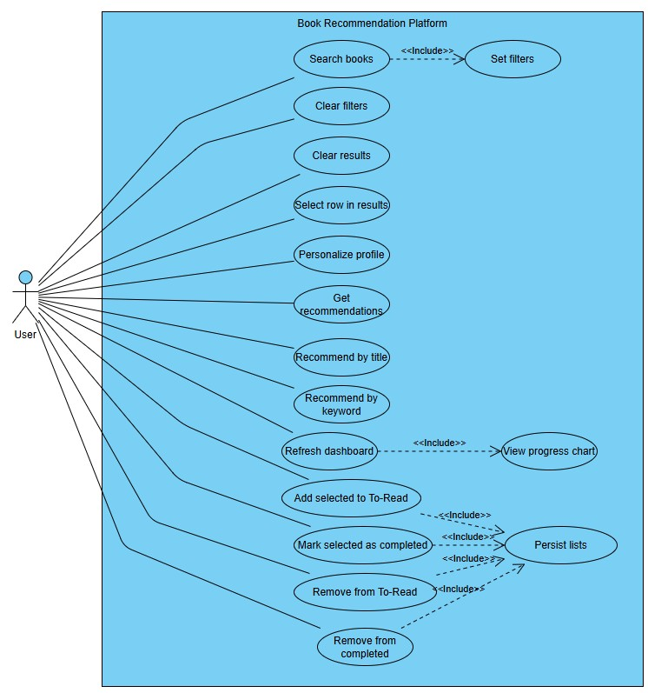
Figure 5.3.1: Use-case diagram

5.4 Use-Case Descriptions
Use Case Name: Search books |  | ID: UC-01 | Importance Level: High
Primary Actor: User | Use Case Type: User Goal
Stakeholders and Interests:
User – wants to quickly find books that match specific criteria.
System – must return accurate, filtered results without errors.

Brief Description:
The user searches the book dataset using the currently defined filters and sees matching books in the results
grid.
Trigger: User presses the Search button.
Type: External
Relationships:
Association: User ↔ Book Recommendation Platform
Include: Set filters (UC-02)
Extend: –
Generalization: –

Normal Flow of Events:
- User enters one or more filters (e.g., title, author, language, genre, difficulty).
- User clicks Search.
- System validates that a dataset is loaded.
- System applies the filters to the internal DataFrame.
- System limits the result set to the configured “Max results to show.”
- System populates the results grid with the matching books.
SubFlows:
- If no filters are entered, the system returns all books up to the maximum limit.
Alternate/Exceptional Flows:
A1: If no dataset is loaded, the system shows a warning message and does not execute the search.
A2: If no books match the filters, the system clears the grid and may show “No results found.”

Use Case Name: Set filters |  | ID: UC-02 | Importance Level: High
Primary Actor: User | Use Case Type: Supporting
Stakeholders and Interests:
User – wants fine-grained control over which books appear.
System – needs consistent filter values before running searches or recommendations.

Brief Description: The user specifies or changes search criteria (text fields and combo boxes) that will be
applied by search and recommendation operations.
Trigger: User edits any filter field or combo box.
Type: External
Relationships:
Association: User ↔ Book Recommendation Platform
Include: –
Extend: –
Generalization: –

Normal Flow of Events:
- User types text into title/author fields and/or chooses values for language, genre, difficulty, and max results.
- System stores the current values in memory as the active filter set.

SubFlows:
S-1: If “Any” is selected for language/genre/difficulty, the system treats that field as “no restriction.”
Alternate/Exceptional Flows:
A1: If the user enters an invalid value for max results (e.g., non-numeric), the system resets to a safe default
(e.g., 300).

Use Case Name: Clear filters |  | ID: UC-03 | Importance Level: Medium
Primary Actor: User | Use Case Type: User Goal
Stakeholders and Interests:
- User – wants to reset all criteria quickly.
- System – must return to default filter state.

Brief Description: The user resets all filter fields to their default values.
Trigger: User clicks Clear Filters.
Type: External
Relationships:
Association: User ↔ Book Recommendation Platform
Normal Flow of Events:
- User clicks Clear Filters.
- System sets title and author fields to empty strings.
- System sets language, genre, and difficulty combo boxes back to “Any.”
- System leaves existing results unchanged until a new search or recommendation is executed.

SubFlows: None
Alternate/Exceptional Flows: None

Use Case Name: Clear results |  | ID: UC-04 | Importance Level: Medium
Primary Actor: User | Use Case Type: User Goal
Stakeholders and Interests:
- User – wants to remove old results before running a new search.
- System – must clear the grid without affecting stored lists.

Brief Description: The user empties the current results grid.
Trigger: User clicks Clear Results.
Type: External
Relationships:
Association: User ↔ Book Recommendation Platform
Include: –
Extend: –
Generalization: –

Normal Flow of Events:
- User clicks Clear Results.
- System removes all rows from the results Treeview.

SubFlows:
Alternate/Exceptional Flows: None

Use Case Name: Select row in results |  | ID: UC-05 | Importance Level: High
Primary Actor: User | Use Case Type: Supporting
Stakeholders and Interests:
- User – wants to choose specific books for list operations.
- System – needs a clear selection before adding or moving books between lists.

Brief Description:
The user highlights one or more rows in the results table, which become candidates for To-Read or
Completed operations.
Trigger: User clicks or Ctrl-clicks rows in the Results grid.
Type: External
Relationships:
Association: User ↔ Book Recommendation Platform
Include: –
Extend: –
Generalization: –

Normal Flow of Events:
- User clicks one or more result rows.
- System updates the internal selection set and visually highlights the chosen rows.

SubFlows:

Alternate/Exceptional Flows:
A1: If the user triggers a list-management action with no rows selected, the system performs no changes and may show an informational message.

Use Case Name: Personalize profile |  | ID: UC-06 | Importance Level: Medium
Primary Actor: User | Use Case Type: User Goal
Stakeholders and Interests:
- User – wants recommendations that reflect favorite authors and genres.
- System – needs a text profile to feed into the recommendation engine.

Brief Description:
The user enters preferred authors and genres that form the basis for personalized recommendations.
Trigger: User fills in “Preferred author(s)” and/or “Preferred genre(s)” fields.
Type: External
Relationships:
Association: User ↔ Book Recommendation Platform
Include: –
Extend: –
Generalization: –

Normal Flow of Events:
- User types author and/or genre preferences in the Personalize section.
- System stores these values and uses them when Get recommendations is invoked.
SubFlows:
Alternate/Exceptional Flows:
A1: If both fields are empty when Get recommendations is used, the system asks the user to enter at least
one preference.

Use Case Name: Get recommendations |  | ID: UC-07 | Importance Level: High
Primary Actor: User | Use Case Type: User Goal
Stakeholders and Interests:
- User – wants a list of books tailored to their preferences.
- System – must generate meaningful ranked suggestions using TF-IDF similarity.

Brief Description:
The system generates a ranked list of book recommendations from the dataset using the personalized profile
and current filters.
Trigger: User clicks Get Recommendations.
Type: External
Relationships:
Association: User ↔ Book Recommendation Platform
Include: Set filters (UC-02), Personalize profile (UC-06)
Extend: –
Generalization: –

Normal Flow of Events:
- User clicks Get Recommendations.
- System verifies that a dataset is loaded.
- System builds a profile query string from preferred authors/genres.
- System applies active filters (language, genre, difficulty, etc.) to narrow the candidate set.
- System runs TF-IDF + cosine similarity to score candidates against the profile.
- System sorts by similarity score and limits to the configured maximum.
- System displays the recommended books in the results grid, including an optional score column.

SubFlows:

Alternate/Exceptional Flows:
A1: If no dataset is loaded, system shows a warning and aborts.
A2: If the profile is empty, system prompts the user to enter preferences first.
A3: If no candidates remain after filtering, system shows “No recommendations found.”

Use Case Name: Recommend by title |  | ID: UC-08 | Importance Level: Medium
Primary Actor: User | Use Case Type: User Goal
Stakeholders and Interests:
- User – wants books similar to a known, liked title.
- System – must find books whose text features resemble the given title.

Brief Description:
The user enters a favorite book title, and the system suggests similar titles.
Trigger: User enters a title and clicks Recommend by Title.
Type: External
Relationships:
Association: User ↔ Book Recommendation Platform
Include: Set filters (UC-02)
Extend: –
Generalization: –

Normal Flow of Events:
- User types a known title in the “I like this title” field.
- User clicks Recommend by Title.
- System verifies that a dataset is loaded.
- System applies active filters to create a candidate subset.
- System locates an anchor vector for the given title or uses the title text directly.
- System computes similarity scores and sorts candidates.
- System displays the top matches in the results grid, excluding the original title itself.

SubFlows:

Alternate/Exceptional Flows:
A1: If the title field is empty, the system shows a prompt asking the user to enter a title.
A2: If no similar titles are found, the system suggests relaxing filters (e.g., set language/genre/difficulty to “Any”).

Use Case Name: Recommend by keyword |  | ID: UC-09 | Importance Level: Medium
Primary Actor: User | Use Case Type: User Goal
Stakeholders and Interests:
- User – wants books related to a topic or theme.
- System – must interpret the keyword and return relevant candidates.

Brief Description:
The user enters a keyword or topic, and the system recommends books whose descriptions and features
match that keyword.

Trigger: User enters a keyword and clicks Recommend by Keyword.
Type: External
Relationships:
Association: • User ↔ Book Recommendation Platform
Include: Set filters (UC-02)
Extend: –
Generalization: –

Normal Flow of Events:
- User types a keyword or phrase in the “Keyword / topic” field.
- User clicks Recommend by Keyword.
- System checks that a dataset is available.
- System filters candidates based on active filters.
- System optionally performs a strict pass requiring that the description contain at least one keyword token.
- System computes similarity scores using TF-IDF and cosine similarity.
- System sorts and shows the top results in the grid.

SubFlows:

Alternate/Exceptional Flows:
A1: If the keyword field is empty, the system prompts the user to enter a keyword.
A2: If no books match, the system suggests relaxing the filters or trying a different keyword.

Use Case Name: Refresh dashboard |  | ID: UC-10 | Importance Level: Medium
Primary Actor: User | Use Case Type: User Goal
Stakeholders and Interests:
- User – wants to see an up-to-date summary of reading progress.
- System – must accurately reflect current To-Read and Completed lists.

Brief Description:
The user updates the dashboard so that the bar chart reflects the current contents of the reading lists.
Trigger: User clicks Refresh Dashboard.
Type: External
Relationships:
Association: User ↔ Book Recommendation Platform
Include: View progress chart (UC-11)
Extend: –
Generalization: –

Normal Flow of Events:
- User clicks Refresh Dashboard.
- System counts items in To-Read and Completed lists.
- System regenerates the bar chart on the dashboard tab.

SubFlows:

Alternate/Exceptional Flows:
A1: If both lists are empty, system displays a “No data yet” message instead of bars.

Use Case Name: View progress chart |  | ID: UC-11 | Importance Level: Low
Primary Actor: User | Use Case Type: Supporting
Stakeholders and Interests:
- User – wants an easy visual overview of their reading status.
- System – must render the chart without crashing.

Brief Description:
The system displays a matplotlib bar chart comparing To-Read and Completed counts.
Trigger: Included when Refresh Dashboard is executed.
Type: External
Relationships:
Association: User ↔ Book Recommendation Platform
Include: –
Extend: –
Generalization: –

Normal Flow of Events:
- System receives the current counts.
- System draws or updates the bar chart on the dashboard canvas.
- User views the chart.

SubFlows:

Alternate/Exceptional Flows:

Use Case Name: Add selected to To-Read |  | ID: UC-12 | Importance Level: High
Primary Actor: User | Use Case Type: User Goal
Stakeholders and Interests:
- User – wants to track books they intend to read.
- System – must avoid duplicates and keep lists consistent.

Brief Description: The user adds selected result rows to the To-Read list.
Trigger: User selects one or more rows and clicks Add selected to To-Read.
Type: External
Relationships:
Association: User ↔ Book Recommendation Platform
Include: Persist lists (UC-16)
Extend: –
Generalization: –

Normal Flow of Events:
- User selects one or more books in the results grid.
- User clicks Add selected to To-Read.
- System collects the titles for the selected rows.
- For each title, system adds it to the To-Read list if it is not already in To-Read or Completed.
- System saves the updated lists (Persist lists).
- System refreshes the To-Read tab.

SubFlows:
Alternate/Exceptional Flows:
A1: If no rows are selected, the system does nothing and may show an informational message.

Use Case Name: Mark selected as completed |  | ID: UC-13 | Importance Level: High
Primary Actor: User | Use Case Type: User Goal
Stakeholders and Interests:
- User – wants to mark books as finished.
- System – must move items between lists correctly.

Brief Description:
The user promotes selected books from the Results grid to the Completed list, removing them from To-Read
if necessary.
Trigger: User selects one or more rows and clicks Mark selected as Completed.
Type: External
Relationships:
Association: User ↔ Book Recommendation Platform
Include: Persist lists (UC-16)
Extend: –
Generalization: –

Normal Flow of Events:
- User selects books in the results grid.
- User clicks Mark selected as Completed.
- System removes each selected title from To-Read if present.
- System adds each title to Completed if it is not already there.
- System saves updated lists.
- System refreshes both To-Read and Completed tabs.

SubFlows:

Alternate/Exceptional Flows:
A1: If no rows are selected, no changes are made.

Use Case Name: Remove from To-Read |  | ID: UC-14 | Importance Level: Medium
Primary Actor: User | Use Case Type: User Goal
Stakeholders and Interests:
- User – wants to clean up their planned reading list.
- System – must update state and UI consistently.

Brief Description: The user removes selected entries from the To-Read list.
Trigger: User selects one or more items in the To-Read tab and clicks Remove from To-Read.
Type: External
Relationships:
Association: User ↔ Book Recommendation Platform
Include: Persist lists (UC-16)
Extend: –
Generalization: –

Normal Flow of Events:
- User selects items in the To-Read Treeview.
- User clicks Remove from To-Read.
- System removes the corresponding titles from the To-Read list in memory.
- System saves the updated lists.
- System refreshes the To-Read tab.

SubFlows:

Alternate/Exceptional Flows:
A1: If no items are selected, no changes are made.

Use Case Name: Remove from completed |  | ID: UC-15 | Importance Level: Medium
Primary Actor: User | Use Case Type: User Goal
Stakeholders and Interests:
- User – wants to edit or clean up the list of finished books.
- System – must keep the Completed list accurate.

Brief Description: The user removes selected entries from the Completed list.
Trigger: User selects one or more items in the Completed tab and clicks Remove from Completed.
Type: External
Relationships:
Association: User ↔ Book Recommendation Platform
Include: Persist lists (UC-16)
Extend: –
Generalization: –

Normal Flow of Events:
- User selects items in the Completed Treeview.
- User clicks Remove from Completed.
- System removes those titles from the Completed list in memory.
- System saves the updated lists.
- System refreshes the Completed tab.

SubFlows:

Alternate/Exceptional Flows:
A1: If no items are selected, no changes occur.

Use Case Name: Persist lists |  | ID: UC-16 | Importance Level: High
Primary Actor: User | Use Case Type: Supporting / Included
Stakeholders and Interests:
- User – wants To-Read and Completed lists to be remembered between sessions.
- System – must safely write and reload state.

Brief Description:
Whenever reading lists change, the system writes the current To-Read and Completed lists to a JSON state
file.
Trigger: Invoked automatically by list-modifying use cases (UC-12, UC-13, UC-14, UC-15).
Type: External
Relationships:
Association: User ↔ Book Recommendation Platform
Include: Add selected to To-Read, Mark selected as completed, Remove from To-Read, Remove from
completed
Extend: –
Generalization: –

Normal Flow of Events:
- Calling use case updates To-Read and/or Completed lists in memory.
- System prepares a state dictionary (e.g., {"to_read": [...], "completed": [...]}).
- System writes the state to the JSON file.

SubFlows:

Alternate/Exceptional Flows:
A1: If writing to the file fails (e.g., permission error), the system logs the problem and may show an error
message; in-memory lists remain updated but changes are not persisted for that run.

5.5 Class Diagram
The class diagram (Figure 5.5.1) for the Book Recommendation Platform describes the main building blocks of the system and how they collaborate. It shows BookApp as the central controller that owns the GUI widgets (TreeView, Figure), uses ScrollableFrame for the sidebar layout, and composes the BookData model for loading, filtering, and recommending books. It also illustrates how ReadingListManager and AppState work together to maintain and persist the To-Read and Completed lists, while RecommendationEngine encapsulates the TF-IDF logic used by BookData.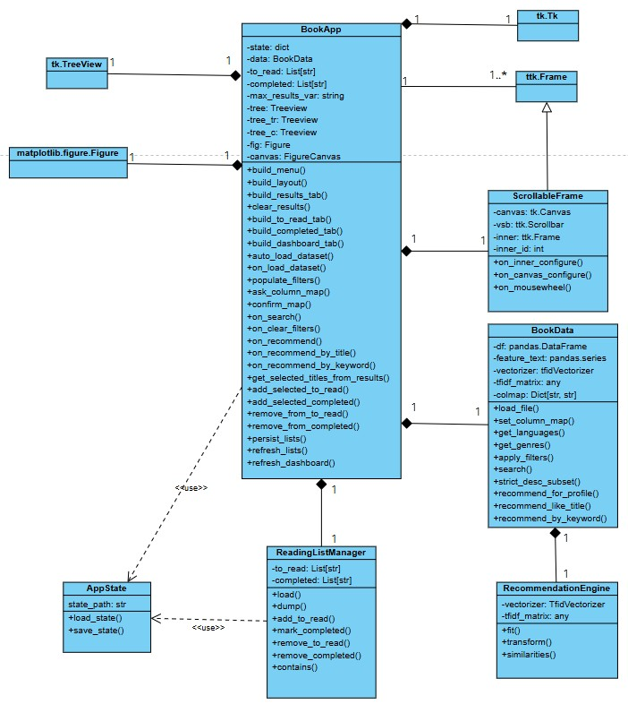

Figure 5.5.1: Class Diagram

5.6 Object Diagram
The object diagram (Figure 5.6.1) provides a runtime snapshot of the Book Recommendation Platform, showing how the classes from the class diagram are instantiated and linked during execution. It depicts a concrete bookapp: BookApp object with specific state (e.g., To-Read and Completed lists), its composed data: BookData and ReadingListManager instances, and the associated RecommendationEngine, ScrollableFrame, AppState, and GUI widgets such as tk.TreeView and matplotlib.figure.Figure. Together, these instances illustrate how the application actually looks in memory while running—how objects reference each other, how reading-list data is stored, and how the UI and recommendation engine are connected in a real scenario.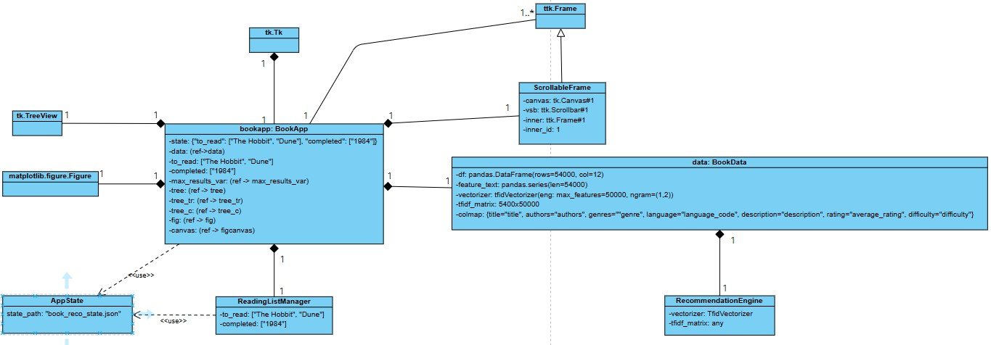

Figure 5.6.1: Object Diagram

5.7 Sequence Diagram
The sequence diagram (Figure 5.7.1) illustrates the dynamic behavior of the Book Recommendation Platform during a typical session. It traces the interaction from the moment the User starts the application, through loading saved state and auto-loading the dataset (via load_state(), BookApp, BookData, the file system, and the TF-IDF vectorizer), to the point where the user clicks Search and the system applies filters, executes search(), and returns a DataFrame of results to be displayed in the Tk/TTK widgets. The diagram also shows the Dashboard refresh fragment, where the bar chart is cleared, redrawn with updated To-Read and Completed counts, and rendered on the FigureCanvasTkAgg, providing a clear view of how control and data flow across components over time.
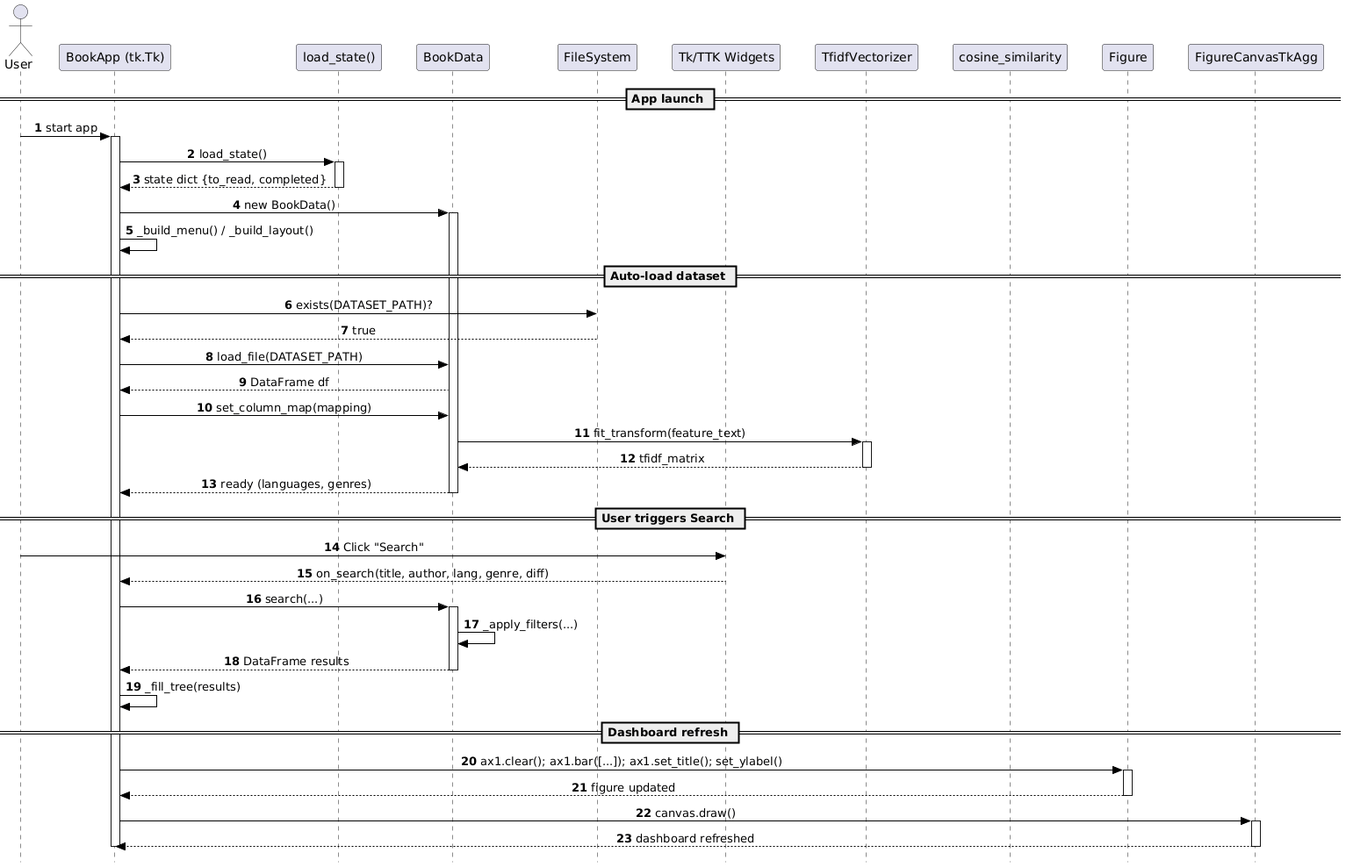

Figure 5.7.1:Sequence Diagram

5.8 State Chart Diagram
The statechart diagram (Figure 5.8.1) for the Book Recommendation Platform shows how the BookApp moves through its main runtime states as the user interacts with the system. The application starts in the Launching state while it builds the UI and handles the dataset, then transitions to Idle, where it waits for user input. From Idle, clicking Search moves the app into the Searching state until results are shown, while clicking any recommendation action moves it into Recommending until suggestions are displayed. When the user adds, removes, or completes books, the app enters the UpdatingLists state to save changes and refresh the dashboard before returning to Idle. Finally, an Exit event takes the application to its terminal state.
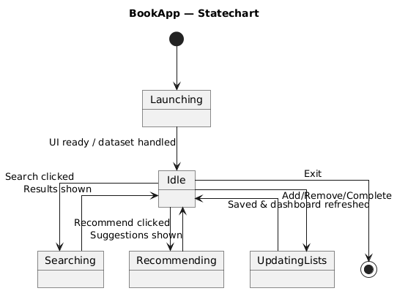
Figure 5.8.1: State Chart Diagram
6. Functional Tests Plan

Test Case ID | Scenario | Precondition | Test Steps | Expected Result
FT-01 | Launch with existing state | book_reco_state.json exists with non-empty to_read and completed lists | 1. Start the application. | To-Read and Completed tabs show the titles stored in the JSON file; no error dialogs appear.
FT-02 | Launch with no state file | book_reco_state.json is deleted or renamed | 1. Start the application. | App launches normally; To-Read and Completed tabs are empty; no crash or blocking error.
FT-03 | Auto-load default dataset successfully | Valid CSV at DATASET_PATH | 1. Start the application. | Info message indicates the dataset was loaded and indexed; language/genre filters are populated; Search and recommendation buttons are enabled.
FT-04 | Auto-load dataset missing | No file present at DATASET_PATH | 1. Start the application. | Warning dialog states dataset was not found and instructs user to use File → Load dataset; app remains usable.
FT-05 | Manual load dataset (auto mapping) | App launched; valid CSV with standard column names | 1. Choose File → Load dataset (CSV/XLSX). 2. Select the CSV. | Dataset loads without mapping dialog; info message confirms readiness; filters are populated from dataset.
FT-06 | Manual load dataset with mapping dialog | App launched; CSV with non-standard column names | 1. Choose File → Load dataset. 2. Select the CSV. 3. In mapping dialog, map Title, Authors, Genre, Language, Description, Rating, Difficulty to correct columns. 4. Click Confirm. | Mapping dialog closes; dataset is indexed; filters are populated; no error shown.
FT-07 | Search books with filters (hit) | Dataset loaded | 1. In Search/Filters section, enter partial title (e.g., “harry”). 2. Set Language to a valid code if available. 3. Click Search. | Results grid shows one or more rows whose titles contain the query and match the selected language.
FT-08 | Search books with filters (miss) | Dataset loaded | 1. Enter a nonsense title (e.g., “zzzzxyz”). 2. Click Search. | Results grid becomes empty; if message is implemented, user sees “No results” or equivalent.
FT-09 | Clear filters | Dataset loaded; some filters filled | 1. Enter any values in title, author, language, genre, difficulty. 2. Click Clear Filters. | Title and author fields are blank; Language/Genre/Difficulty are reset to “Any”; results grid remains unchanged.
FT-10 | Clear results | Dataset loaded; results grid currently has rows | 1. Click Clear Results. | All rows disappear from the results grid; filters and lists are not modified.
FT-11 | Get recommendations from profile | Dataset loaded; at least one book matching author/genre exists | 1. In Personalize section, enter preferred author and/or genre. 2. Optionally set Language/Genre/Difficulty filters. 3. Click Get Recommendations. | Results grid displays a ranked list of suggested books; score column is filled (if present); count does not exceed “Max results to show”.
FT-12 | Recommend by title | Dataset loaded | 1. Type a known title from the dataset in I like this title. 2. Click Recommend by Title. | Results grid shows similar books; original title does not appear in the list; number of rows ≤ max results.
FT-13 | Recommend by keyword (no input) | Dataset loaded | 1. Leave Keyword / topic empty. 2. Click Recommend by Keyword. | Informational dialog asks the user to enter a keyword; no change to results grid.
FT-14 | Recommend by keyword (no matches) | Dataset loaded | 1. Enter unlikely keyword (e.g., “qwertyplanet”). 2. Click Recommend by Keyword. | Either an empty results grid or message indicating no matches; app remains responsive.
FT-15 | Add selected to To-Read | Dataset loaded; at least one search/recommendation result visible | 1. Select one or more rows in the results grid. 2. Click Add selected to To-Read. 3. Switch to To-Read tab. 4. Close and reopen the app. | Selected titles appear once in the To-Read tab; they are stored in the JSON file and reloaded after restart.
FT-16 | Mark selected as Completed | Dataset loaded; one book already in To-Read | 1. Run a search so that the same title appears in results. 2. Select that row. 3. Click Mark selected as Completed. 4. Check To-Read and Completed tabs. | Title is removed from To-Read, added once to Completed, and persisted to JSON.
FT-17 | Prevent duplicates in lists | Dataset loaded; a title already in To-Read | 1. Select a result row whose title is already in To-Read. 2. Click Add selected to To-Read again. | To-Read list still contains only one instance of that title; no duplicate row appears.
FT-18 | Remove from To-Read | To-Read tab contains at least one item | 1. Open To-Read tab. 2. Select a title. 3. Click Remove from To-Read. 4. Close and reopen the app. | Title disappears from To-Read tab immediately and remains absent after restart; Completed list is unchanged.
FT-19 | Remove from Completed | Completed tab contains at least one item | 1. Open Completed tab. 2. Select a title. 3. Click Remove from Completed. 4. Close and reopen the app. | Title disappears from Completed tab and does not reappear after restart; To-Read list is unaffected.
FT-20 | Refresh dashboard with data | At least one title in To-Read and one in Completed | 1. Open Dashboard tab. 2. Click Refresh Dashboard. | Bar chart shows two bars (To-Read, Completed) with heights matching list counts; chart title reflects total tracked books.
FT-21 | Refresh dashboard with no data | To-Read and Completed lists empty | 1. Open Dashboard tab. 2. Click Refresh Dashboard. | Dashboard displays a “No data yet / Add books to lists” style message instead of bars; no error raised.
FT-22 | Max results limit | Dataset loaded; Max results spinbox set to low value (e.g., 10) | 1. Set “Max results to show” to 10. 2. Run a search or Get Recommendations that would normally return more than 10 rows. | Results grid contains no more than 10 rows.
FT-23 | Error handling when dataset not loaded | App launched; default dataset missing; no manual load done | 1. Click Search. 2. Click Get Recommendations. 3. Click Recommend by Title. | For each action, a warning dialog indicates that a dataset must be loaded; no crash occurs and no results grid update is attempted.

7. System Design Specifications
7.1 Deployment Diagram
The deployment diagram (Figure 7.1.1) shows how the Book Recommendation Platform is physically hosted and executed in the user’s environment. It depicts the application running as a BookApp process inside a Python 3.x runtime on a Windows 10/11 PC, reading and writing local artifacts (books_enriched.csv and book_reco_state.json) from the user’s file system, and relying on installed site-packages (pandas, scikit-learn, matplotlib, and tkinter/ttk) to provide data handling, recommendation logic, charting, and the GUI.
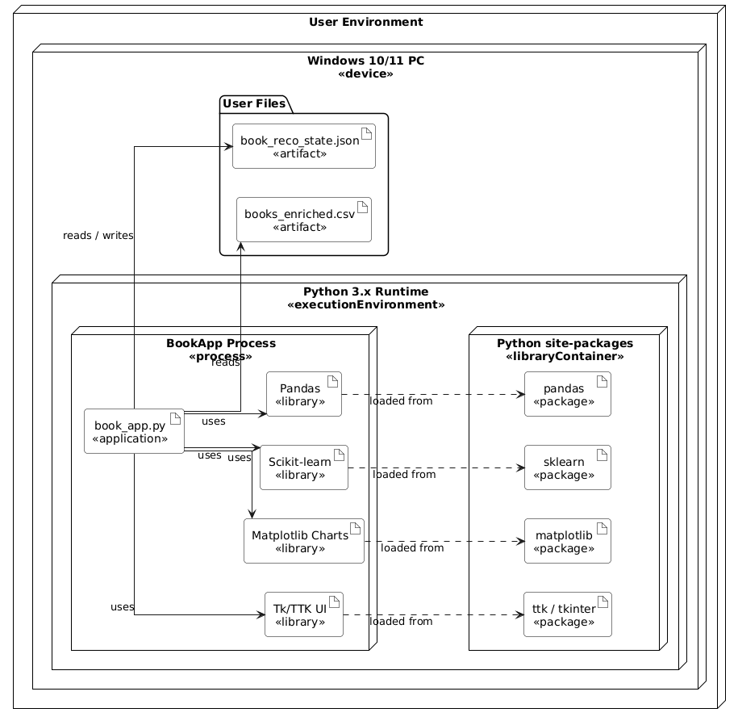
Figure 7.1.1: Deployment Diagram

7.2 Package Diagram
The package diagram (Figure 7.2.1) organizes the Book Recommendation Platform into logical layers and shows how they depend on one another. The Core package contains BookApp, BookData, and ScrollableFrame, which build the UI and implement the main search/recommendation logic. The Extras package groups helper components such as ReadingListManager and recommendationEngine that manage reading lists and TF-IDF similarity, while the Utilities package (e.g., AppState, ListUtils) handles generic load/save and state I/O. Finally, the External (Library) package captures the third-party UI and plotting types from Tk/TTK and Matplotlib that the core classes use to render the interface and charts.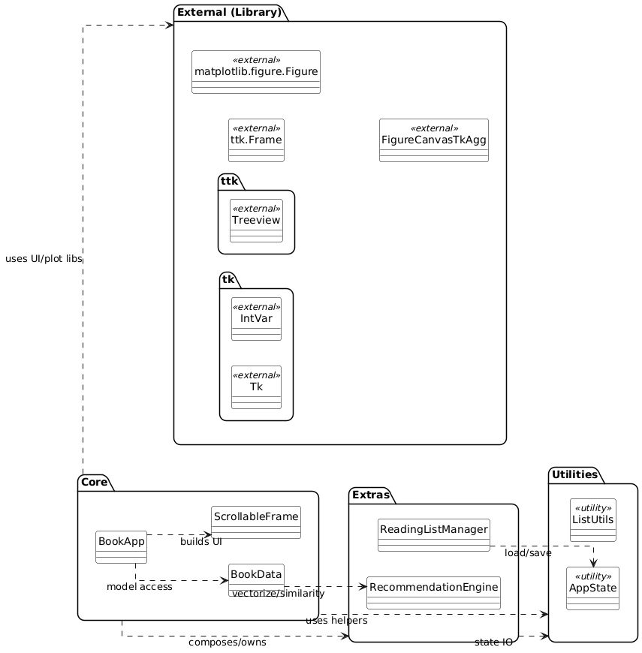
Figure 7.2.1: Package Diagram

7.3 Database tables
Table | Columns | PK | FKs
users | • user_id INTEGER (auto-increment)  • email VARCHAR UNIQUE  • password_hash CHAR(64)  • notifications BOOLEAN | user_id | –
movies | • movie_id INTEGER (auto-increment)  • title VARCHAR  • clean_title VARCHAR  • year SMALLINT  • genres TEXT | movie_id | –
watchlists | • watchlist_id INTEGER (auto-increment)  • user_id INTEGER  • movie_id INTEGER  • saved_at TIMESTAMP | watchlist_id | user_id → users.user_id  movie_id → movies.movie_id
ratings | • rating_id INTEGER (auto-increment)  • user_id INTEGER  • movie_id INTEGER  • rating TINYINT  • rated_at TIMESTAMP | rating_id | user_id → users.user_id  movie_id → movies.movie_id
genre_preferences | • pref_id INTEGER (auto-increment)  • user_id INTEGER  • weather_condition VARCHAR  • genres TEXT | pref_id | user_id → users.user_id
user_genres | • user_id INTEGER  • genre VARCHAR | (user_id, genre) | user_id → users.user_id
weather_cache | • cache_id INTEGER (auto-increment)  • location VARCHAR  • weather VARCHAR  • temperature DECIMAL  • icon_code VARCHAR  • fetched_at TIMESTAMP | cache_id | –

- users – holds basic user information for people who own reading lists in the system.
- books – master catalog of all available books, including textual metadata and difficulty level.
- authors – normalized list of authors so that a book can be linked to multiple authors.
- genres – catalog of genres used for filtering and recommendation.
- languages – lookup table for language codes and human-readable names.
- reading_list_items – one row for each book a user tracks, with a status showing whether it is To-Read or Completed.
- book_authors – bridge table that models the many-to-many relationship between books and authors.
- book_genres – bridge table that models the many-to-many relationship between books and genres.

7.4 ER Diagram
The ER diagram (Figure 7.4.1) defines the logical data model behind the Book Recommendation Platform. It centers on the Book entity, which stores title, raw authors string, description, language code, rating, and difficulty, and links to Language (via language_code), Author, and Genre through the bridge tables BookAuthor and BookGenre to support many-to-many relationships. A User owns multiple ReadingListItem records, each referencing a specific Book with a status of To-Read or Completed and an added_at timestamp, providing a normalized representation of the reading lists shown in the UI. This schema corresponds to the flattened books_enriched.csv dataset used by the application, while making the underlying relationships explicit for filtering and recommendation logic.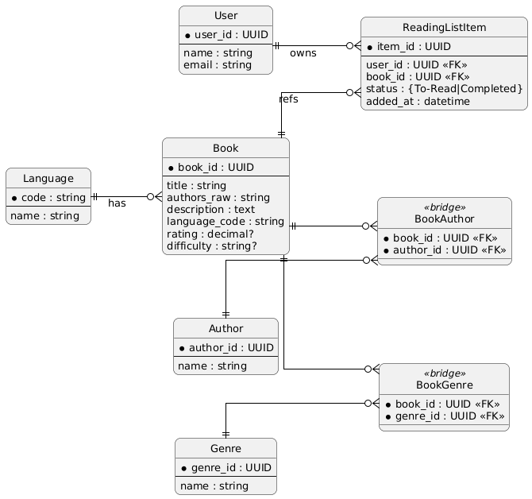

Figure 7.4.1: ER Diagram
7.5 Windows Navigation Diagram
The windows navigation diagram (Figure 7.5.1) illustrates how a user moves through the Book Recommendation Platform’s interface, showing the main application window, its tabs (Results/Recommendations, To-Read, Completed, Dashboard), and auxiliary dialogs (file open, column mapping, message boxes), so that the overall flow between screens and key buttons is clear at a glance.
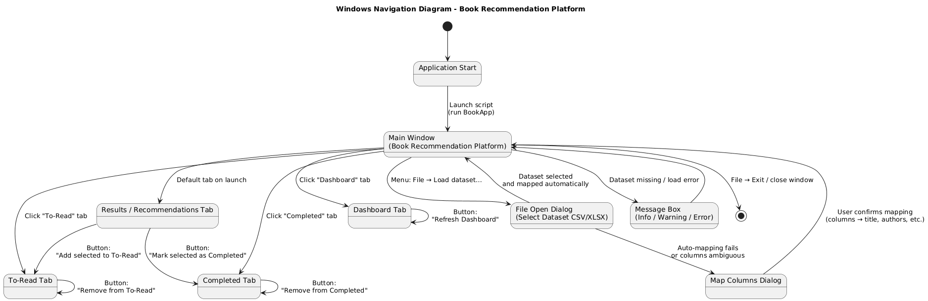

Figure 7.5.1: Windows Navigation Diagram

7.6 Draft of User Interface
Following image (Figure 7.6.1) is the draft of user interface.

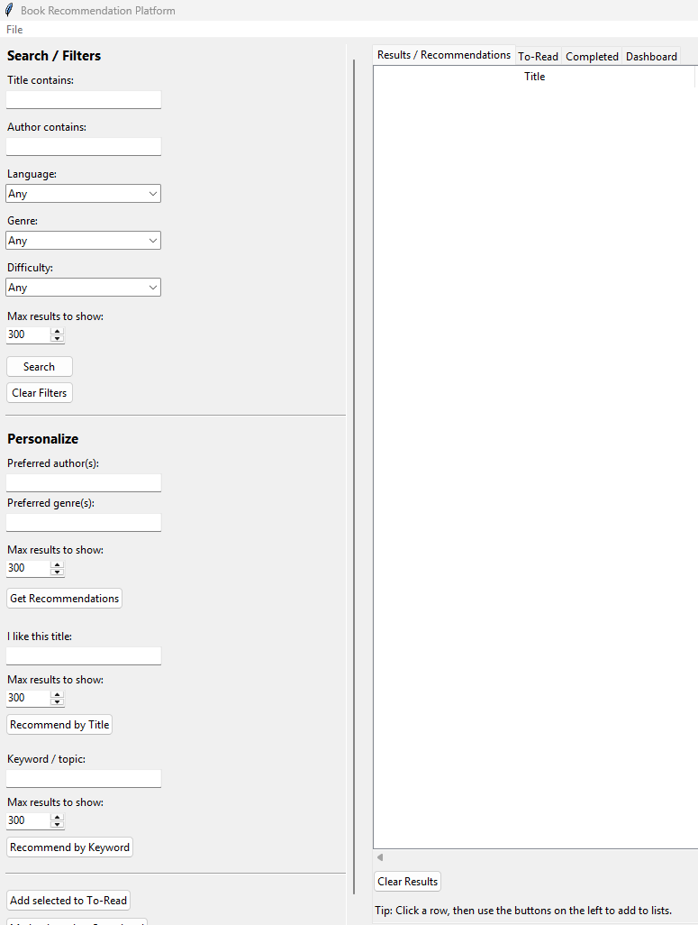

Figure 7.6.1: Draft of User Interface

8. Integration Tests Plan
Test Case ID | Integration Scenario | Precondition | Test Steps | Expected Result
IT-01 | App launch ↔ AppState (load_state) | book_reco_state.json exists with some to_read and completed titles | 1. Start the application. | load_state() is called; BookApp’s to_read and completed lists are populated from JSON and both To-Read and Completed tabs show the same titles.
IT-02 | App launch ↔ Auto-load dataset (BookData + file system) | Valid books_enriched.csv at DATASET_PATH | 1. Start the application. | BookData.load_file() reads the CSV, set_column_map() builds TF-IDF features, and filters (Language/Genre) are populated; info dialog confirms dataset is ready.
IT-03 | Manual dataset load ↔ Column-mapping dialog | App running; choose a CSV with non-standard column names | 1. Use File → Load dataset. 2. Select the CSV. 3. In the mapping dialog, map Title/Authors/Genre/Language/etc. to the correct columns and confirm. | ask_column_map() and _confirm_map() successfully pass the mapping into BookData.set_column_map(); no error message; filters are updated and searching works on the new file.
IT-04 | Search flow: BookApp ↔ BookData.search ↔ Results Treeview | Dataset loaded | 1. Enter valid filter values (e.g., Title contains “hobbit”). 2. Click Search. | on_search() calls BookData.search(), which calls _apply_filters() and returns a DataFrame; _fill_tree() inserts rows into the Treeview and the visible results match the filters.
IT-05 | Profile recommendations: BookApp ↔ BookData.recommend_for_profile ↔ Results Treeview | Dataset loaded; at least one author/genre in dataset that matches preferences | 1. Enter preferred author and/or genre in Personalize section. 2. Optionally set Language/Genre/Difficulty filters. 3. Click Get Recommendations. | on_recommend() builds a profile string, BookData.recommend_for_profile() computes cosine similarity using TF-IDF, and _fill_tree() shows a ranked list of suggestions with a filled “score” column.
IT-06 | Title/keyword recommendations: UI ↔ recommend_like_title / recommend_by_keyword | Dataset loaded | 1. For title flow: enter a known book in I like this title, click Recommend by Title. 2. For keyword flow: enter a topic in Keyword / topic, click Recommend by Keyword. | Each handler calls the corresponding BookData method, which reuses _apply_filters() and TF-IDF; the Results grid is updated with similar books ordered by score and no crashes occur when there are zero or many matches.
IT-07 | Reading list UI ↔ AppState.save_state (To-Read) | Dataset loaded; at least one row in Results grid | 1. Select a book in Results. 2. Click Add selected to To-Read. 3. Close the app. 4. Restart the app. | add_selected_to_read() updates to_read, calls persist_lists(), which writes JSON; after restart, load_state() restores the same title in the To-Read tab.
IT-08 | Reading list transitions: Results ↔ To-Read ↔ Completed | Dataset loaded; book appears in Results and To-Read | 1. Ensure a title is present in To-Read. 2. Run a search so the same title appears in Results. 3. Select that row and click Mark selected as Completed. | add_selected_completed() removes the title from to_read, adds it to completed, calls persist_lists(), and refresh_lists() shows the change in both tabs; JSON reflects the updated status.
IT-09 | Dashboard: Reading lists ↔ Matplotlib Figure ↔ FigureCanvasTkAgg | At least one title in To-Read and one in Completed | 1. Open Dashboard tab. 2. Click Refresh Dashboard. | refresh_dashboard() reads to_read/completed, updates the Matplotlib Figure, and canvas.draw() renders a bar chart whose counts match the list sizes; no exceptions are raised.
IT-10 | Error handling: list actions with no selection | Dataset loaded; Results/To-Read/Completed may be empty or non-selected | 1. With no row selected in Results, click Add selected to To-Read and Mark selected as Completed. 2. With no row selected in To-Read, click Remove from To-Read. 3. With no row selected in Completed, click Remove from Completed. | Each handler returns gracefully without modifying lists or raising errors; the app remains responsive.
IT-11 | Error handling: search/recommend without dataset | Rename or remove dataset; ensure no manual load performed | 1. Start the app and dismiss any warning. 2. Click Search, Get Recommendations, Recommend by Title, and Recommend by Keyword. | Each action checks self.data.df is None, shows a warning message (“Load a dataset first”) and does not attempt to call BookData methods; no crash occurs.
IT-12 | End-to-end session: launch → search → recommend → lists → dashboard → restart | Valid dataset and writable JSON path | 1. Start app (auto-load dataset). 2. Run a search and view results. 3. Use Get Recommendations based on a profile. 4. Add one result to To-Read and mark another as Completed. 5. Open Dashboard and refresh. 6. Close and restart app. | All components (BookApp, BookData, TF-IDF, AppState, list management, Matplotlib) work together: results and recommendations appear correctly, reading lists update, dashboard reflects counts, and after restart the same list state is restored.

9. Programming environment and tools:
Language & Runtime
- Implementation language: Python 3.x (developed and tested on Python 3.10).
- A dedicated virtual environment (via venv) is used so that project dependencies do not interfere with other Python installations on the machine.
Target Operating Systems
- Primary target: Windows 10/11 desktop.
- The code is written using only cross-platform libraries (Tkinter, pandas, scikit-learn, matplotlib), so it can also run on macOS and most Linux distributions with Python 3.x installed.
IDE / Editor
- Source code was developed using Visual Studio Code with the Python extension (linting, formatting, and debugging support).
- Any modern Python IDE (e.g., PyCharm, Thonny) can be used to open and run the project.
Version Control
- Git is used to track changes in the source files.
- A remote repository (e.g., GitHub) can host the project for backup and collaboration, including issues and pull-request history.
Core Libraries and Frameworks
- Tkinter / ttk (standard library) for the graphical user interface: windows, frames, labels, entry fields, comboboxes, buttons, and treeviews.
- pandas for loading and manipulating the enriched book dataset (books_enriched.csv) as DataFrames.
- scikit-learn (sklearn.feature_extraction.text.TfidfVectorizer and sklearn.metrics.pairwise.cosine_similarity) to build the TF-IDF matrix and compute similarity scores for recommendations.
- matplotlib (plus FigureCanvasTkAgg) for rendering the bar chart that summarizes To-Read vs Completed books on the dashboard tab.
- Python standard library modules such as json, os, re, and datetime for state persistence, file handling, string processing, and timestamps.
Testing & Quality Assurance
- Functional and integration scenarios are validated using a combination of manual tests and automated scripts.
- unittest or pytest can be used to implement automated tests for BookData, recommendation methods, and AppState load/save helpers.
Design & Documentation Tools
- PlantUML (or a similar UML tool) was used to produce the use case, class, object, sequence, statechart, package, deployment, and ER diagrams included in the report.
- Project documentation, including the README and this report, is written in Markdown.
Packaging & Deployment
- Dependencies are listed in a requirements.txt file generated using pip freeze inside the virtual environment.
- For distribution to non-technical users, the application can be bundled as a standalone desktop executable using PyInstaller (or a similar packaging tool), so users can run the Book Recommendation Platform without installing Python manually.

10. Unit and Module Tests Plan
The unit and module tests for the Book Recommendation Platform verify that both individual functions and larger subsystems work correctly before full integration. Unit tests focus on core pieces like state persistence and BookData search/recommendation logic, while module tests exercise end-to-end flows inside each module, such as the BookData pipeline, reading list management, and the dashboard update process. Together, they provide confidence that the application’s core logic is reliable and ready for GUI and integration testing.
1. Unit Tests
Test ID | Module | Scenario | Precondition | Test Steps | Expected Result
UT-01 | UserManager | Register new user (success) | Empty users.json | 1. Instantiate UserManager with temp file.  2. Call register_user("a@x.com","pw") | Returns True; users.json contains one user record.
UT-02 | UserManager | Register existing email (failure) | users.json has user | 1. Preload users.json with "b@x.com".  2. Call register_user("b@x.com","pw") | Returns False; no duplicate entry in file.
UT-03 | UserManager | Sign in valid credentials | User c@x.com in file | 1. Ensure users.json contains hashed pw.  2. Call sign_in_user("c@x.com","pw") | Returns True.
UT-04 | UserManager | Sign in invalid credentials | User d@x.com in file | 1. Call sign_in_user("d@x.com","wrong") | Returns False.
UT-05 | UserManager | Reset password (success) | User e@x.com in file | 1. Call reset_password("e@x.com","new")  2. Reload file and verify hashed "new" | Returns True; password updated.
UT-06 | UserManager | Delete account | User f@x.com in file | 1. Call delete_account("f@x.com")  2. Reload file | Returns True; user removed.
UT-07 | WeatherService | Fetch weather (success) | Mock requests.get 200 | 1. Mock response JSON with weather[0].description, main.temp, weather[0].icon.  2. Call fetch_weather_data("City") | Returns dict with capitalized weather, temperature, icon.
UT-08 | WeatherService | Fetch weather (failure) | Mock requests.get error | 1. Mock requests.get to raise RequestException.  2. Call fetch_weather_data("BadCity") | Returns {"weather":"Unavailable",...}
UT-09 | MovieRecommender | extract_year parsing | N/A | 1. Call extract_year("Name (1999)")  2. Call with "Name" | Returns 1999 for first; None for second.
UT-10 | MovieRecommender | clean_title removal | N/A | 1. Call clean_title("Movie (2020)") | Returns "Movie".
UT-11 | MovieRecommender | Load missing CSV | Nonexistent path | 1. Instantiate with bad path | movies_data.empty == True.
UT-12 | MovieRecommender | Load valid CSV | Provide minimal CSV file | 1. Write CSV with title and genre columns.  2. Instantiate class | movies_data contains same number of rows.

2. Module Tests
Test ID | Module | Scenario | Precondition | Test Steps | Expected Result
MT-01 | BookData – Load & Map | End-to-end load and column mapping | Small test CSV with columns: title, authors, genre, language_code, description, average_rating, difficulty | 1. Instantiate BookData. 2. Call load_file(path) with the test CSV. 3. Call set_column_map() with a mapping that uses all of these columns. | df is non-empty; internal columns (_title_main, _authors, _genres_list, _language, _description, _rating, _difficulty) are created; vectorizer and tfidf_matrix are initialized without errors.
MT-02 | BookData – Search Pipeline | Search with multiple filters applied together | MT-01 completed; BookData fully initialized | 1. Call search() with a title keyword, an author keyword, and a specific language and difficulty. | Returned DataFrame contains only rows that respect all provided filters; columns are exactly title, authors, language, rating, difficulty.
MT-03 | BookData – Language & Genre Filters | Populate distinct filter options | MT-01 completed | 1. Call get_languages(). 2. Call get_genres(). | get_languages() returns sorted distinct language codes present in _language. get_genres() returns a sorted set of unique genres from _genres_list; no duplicates or empty entries.
MT-04 | BookData – Profile Recommendations | Recommendations from author/genre profile | MT-01 completed; at least a few rows match a given author/genre | 1. Call recommend_for_profile("fantasy dragons", k=5, allow_language="Any", genre_filter="Any", difficulty="Any"). | Result contains up to 5 rows with a score column; scores are in descending order; suggestions are drawn from the same underlying DataFrame that was loaded in MT-01.
MT-05 | BookData – Recommend by Title | Similar-title recommendation flow | MT-01 completed; dataset contains a well-known title (e.g., “The Hobbit”) | 1. Call recommend_like_title("The Hobbit", k=5, allow_language="Any", genre_filter="Any", difficulty="Any"). | Returned DataFrame has at most 5 rows, includes score, and does not include “The Hobbit” itself; function completes without error even if the anchor title appears multiple times in the dataset.
MT-06 | BookData – Recommend by Keyword | Topic-based recommendation | MT-01 completed; some descriptions include the word “magic” | 1. Call recommend_by_keyword("magic school", k=5, allow_language="Any", genre_filter="Any", difficulty="Any"). | All returned rows have non-empty score values and come from books where description/feature text is relevant to “magic”; when fewer than 5 matches exist, size equals the number of matches.
MT-07 | Reading Lists + AppState | To-Read / Completed with persistence | Temporary directory for JSON; BookData not required | 1. Point APP_STATE_PATH to a temp file. 2. Initialize state = {"to_read": [], "completed": []}. 3. Append two titles to to_read, one to completed. 4. Call save_state(state). 5. Call load_state() and inspect. | Data round-trips correctly: titles are restored exactly as written; no extra keys are added; no exception on read/write.
MT-08 | BookApp – List Management | From results to To-Read and Completed | Dataset stubbed or small sample DataFrame; BookApp created with an injected BookData filled with test rows | 1. Insert a few rows manually into BookApp.tree (Results). 2. Select one title and call add_selected_to_read(). 3. Select another title and call add_selected_completed(). | to_read and completed lists inside BookApp are updated as expected; duplicate prevention works (same title is not added twice); To-Read and Completed Treeviews reflect internal list contents.
MT-09 | Dashboard Module | Reading lists reflected in bar chart | BookApp instantiated; to_read and completed pre-populated with test data | 1. Set bookapp.to_read = ["A","B","C"]. 2. Set bookapp.completed = ["D"]. 3. Call refresh_dashboard(). | Matplotlib Figure shows two bars (To-Read=3, Completed=1) and the title includes “Total tracked: 4”; no drawing errors occur.
MT-10 | Dataset Loading Workflow | Auto-load + filter population | Valid books_enriched.csv at DATASET_PATH; BookApp created normally | 1. Start BookApp (which calls _auto_load_dataset()). 2. After window creation, inspect lang_cb.values and genre_cb.values. | BookData.load_file() and set_column_map() are invoked; language and genre comboboxes contain “Any” plus at least one concrete option from the dataset, confirming the full module pipeline from file → BookData → BookApp UI.

11. Results of Unit and Module Tests, Integration Tests and Functinal Tests
Unit & Module Tests Results
Category | Tests Executed | Passed | Coverage
Unit Tests | 12 | 12 | –
Module Tests | 10 | 10 | –
Combined | 22 | 22 | 100%

Integration Tests Results
Test Case ID | Description | Result
IT-01 | App launch with AppState (load_state and initial lists) | Pass
IT-02 | Auto-loading books_enriched.csv into BookData on startup | Pass
IT-03 | Manual dataset load with column-mapping dialog | Pass
IT-04 | Search flow: BookApp ↔ BookData.search ↔ Results Treeview | Pass
IT-05 | Profile-based recommendations from UI to BookData and back | Pass
IT-06 | Recommend by title / keyword end-to-end | Pass
IT-07 | Results → To-Read / Completed lists ↔ JSON persistence | Pass
IT-08 | Moving items from To-Read to Completed via “Mark Completed” | Pass
IT-09 | Dashboard refresh: reading lists ↔ Matplotlib bar chart | Pass
IT-10 | Graceful handling when dataset is missing for search/recommend | Pass
IT-11 | List operations with no selection (no-crash behavior) | Pass
IT-12 | Full user session: launch → search → recommend → lists → restart | Pass

Functional Tests Results
Test Case ID | Scenario | Result
FT-01 | Launch with existing state JSON | Pass
FT-02 | Launch with no existing state file | Pass
FT-03 | Auto-load default dataset successfully | Pass
FT-04 | Auto-load dataset missing (warning shown) | Pass
FT-05 | Manual dataset load with automatic column mapping | Pass
FT-06 | Manual dataset load with mapping dialog | Pass
FT-07 | Search books with filters and matching results | Pass
FT-08 | Search books with filters and no matches | Pass
FT-09 | Clear filters in Search/Filters panel | Pass
FT-10 | Clear Results grid | Pass
FT-11 | Get recommendations from Personalize (profile-based) | Pass
FT-12 | Recommend by Title | Pass
FT-13 | Recommend by Keyword with no input | Pass
FT-14 | Recommend by Keyword with no matching books | Pass
FT-15 | Add selected books from Results to To-Read | Pass
FT-16 | Mark selected books as Completed | Pass
FT-17 | Prevent duplicate entries in reading lists | Pass
FT-18 | Remove books from To-Read | Pass
FT-19 | Remove books from Completed | Pass
FT-20 | Refresh dashboard with existing reading list data | Pass
FT-21 | Refresh dashboard with empty reading lists | Pass
FT-22 | Enforce “Max results to show” limit | Pass
FT-23 | Error handling when actions are triggered without dataset | Pass

12. Demo
The following image (Figure 12.1) shows the main GUI of the application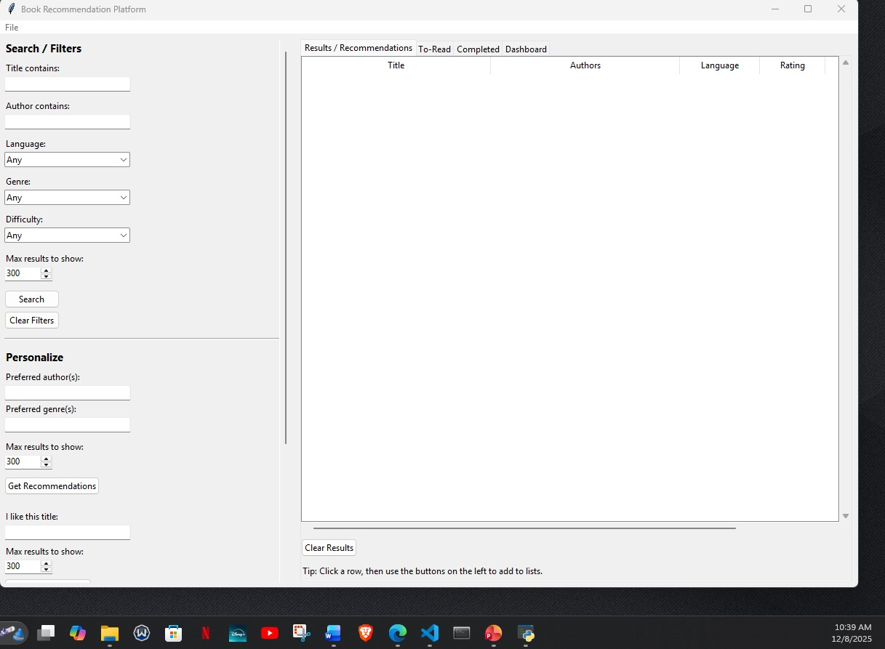
Figure 12.1

The following image (Figure 12.2) shows the results for the title containing “harry potter”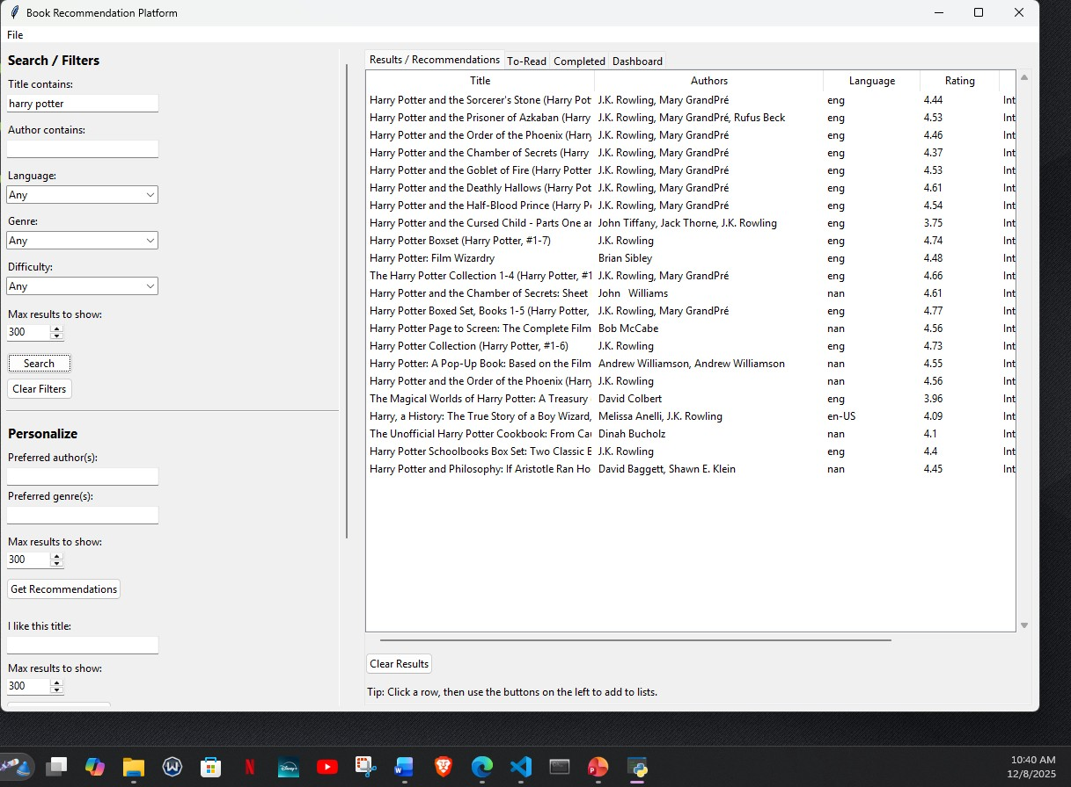
Figure 12.2
The following image (Figure 12.3) shows the results for the author contains “rowling”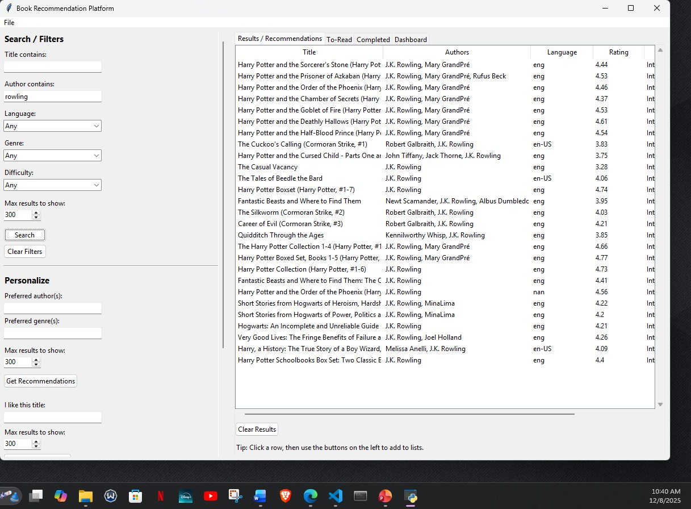
Figure 12.3

The following image (Figure 12.4) shows all the “Beginner” level books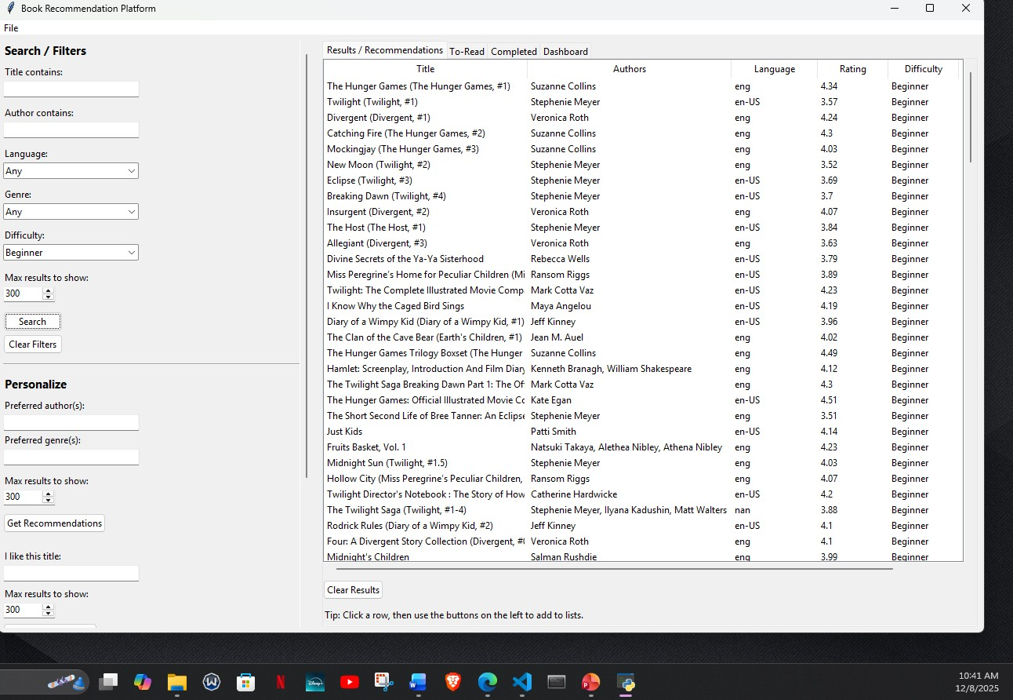
Figure 12.4

The following image (Figure 12.5) shows the preferred author results for the word “stevenson”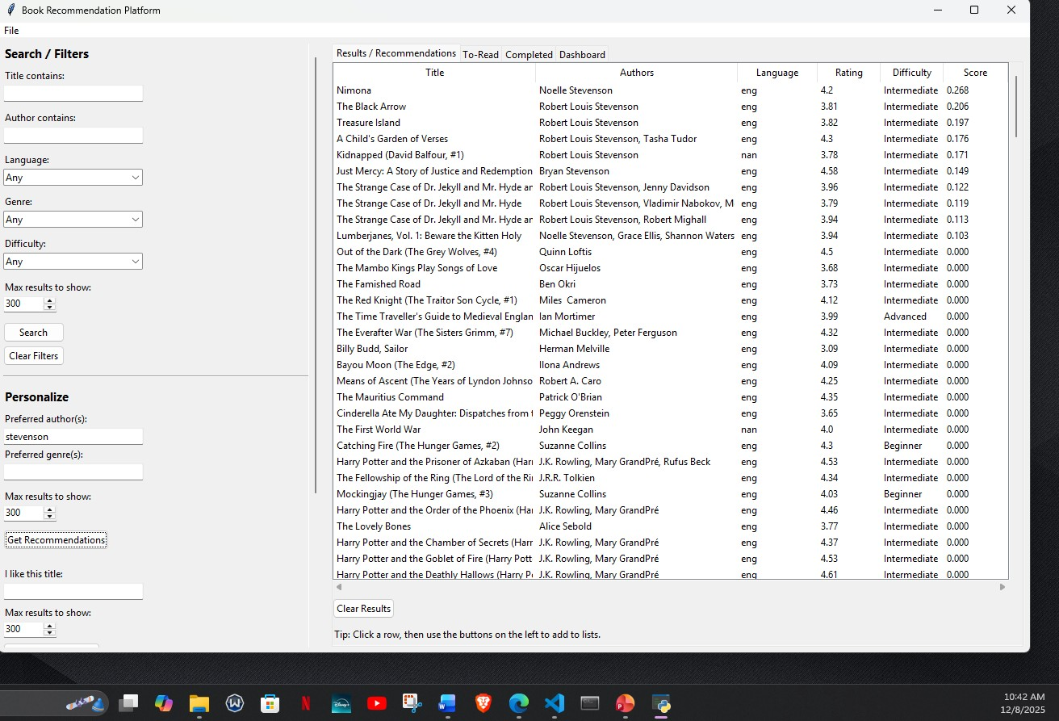
Figure 12.5

The following image (Figure 12.6) shows the results for the preferred genre “action”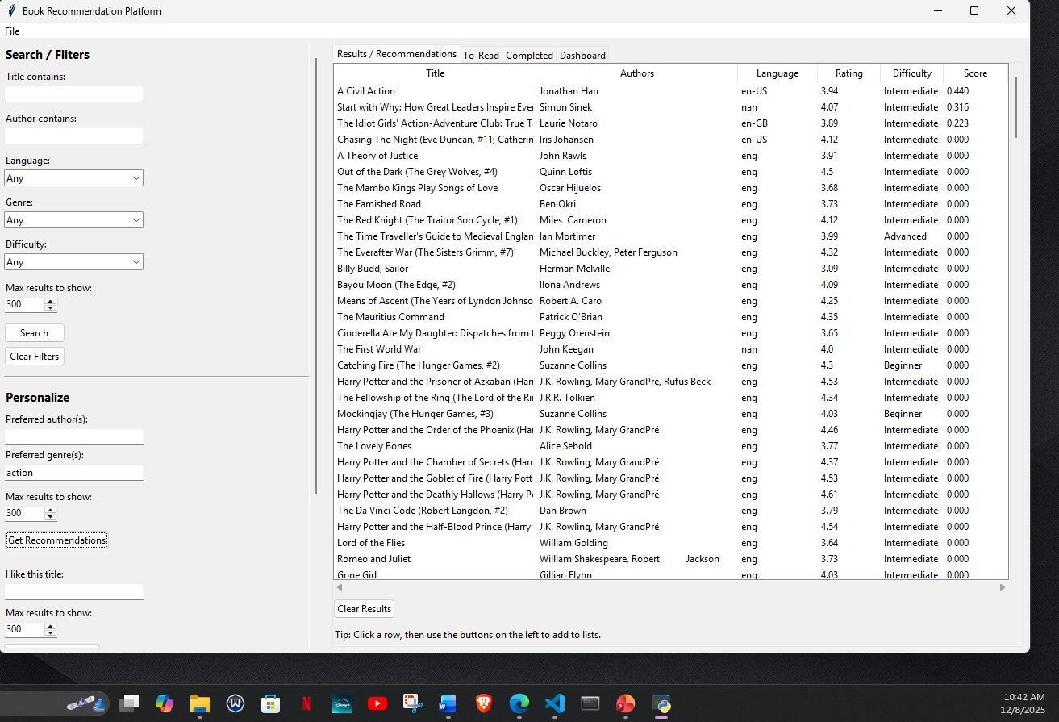
Figure 12.6

The following image (Figure 12.7) shows the results for recommend by keyword i.e. the word “love”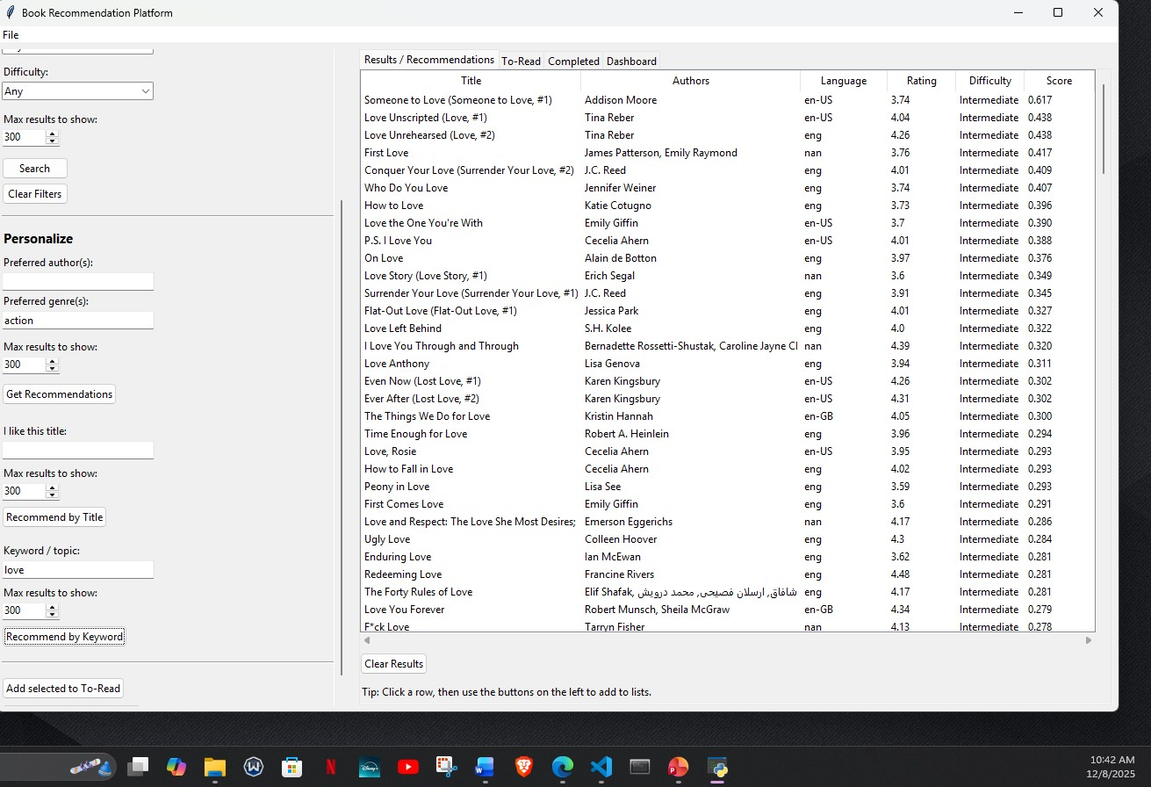
Figure 12.7

The following image (Figure 12.8) shows the list of books added to the To-Read section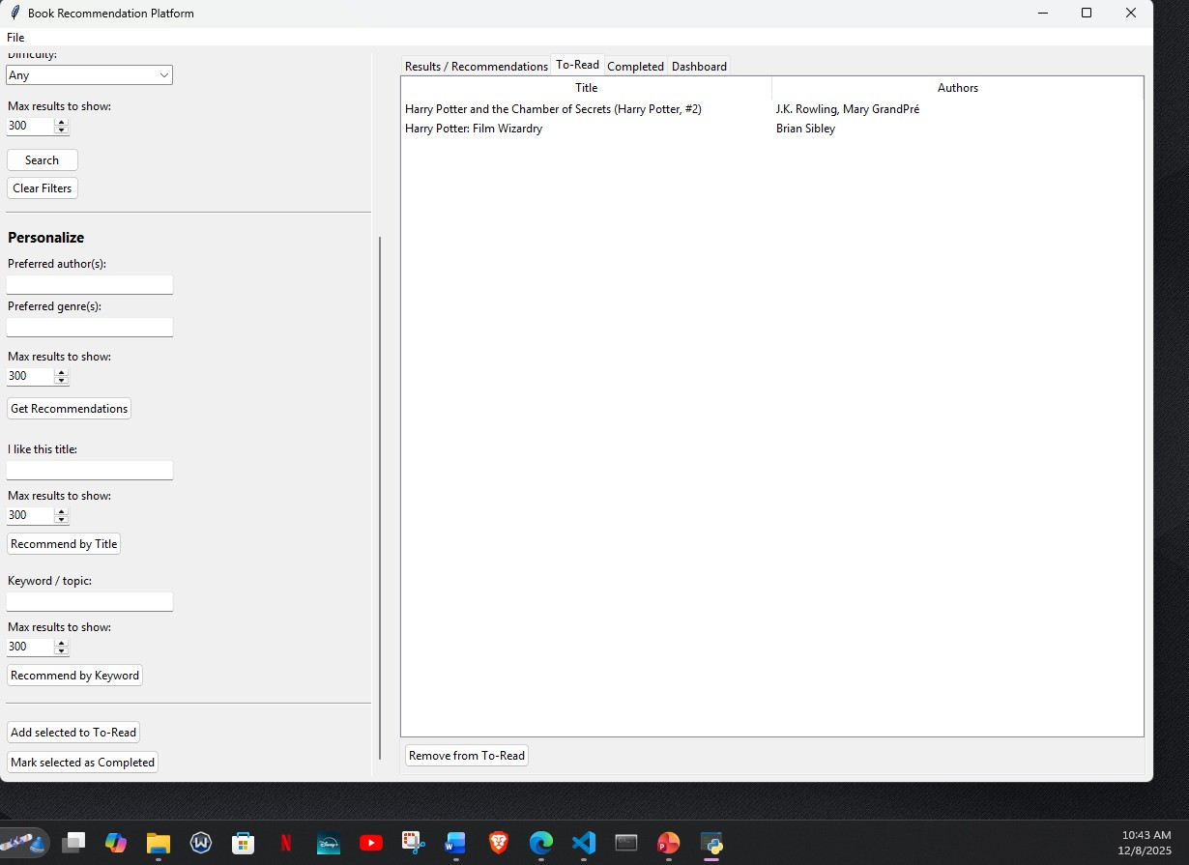
Figure 12.8

The following image (Figure 12.9) shows the list of books added to the completed section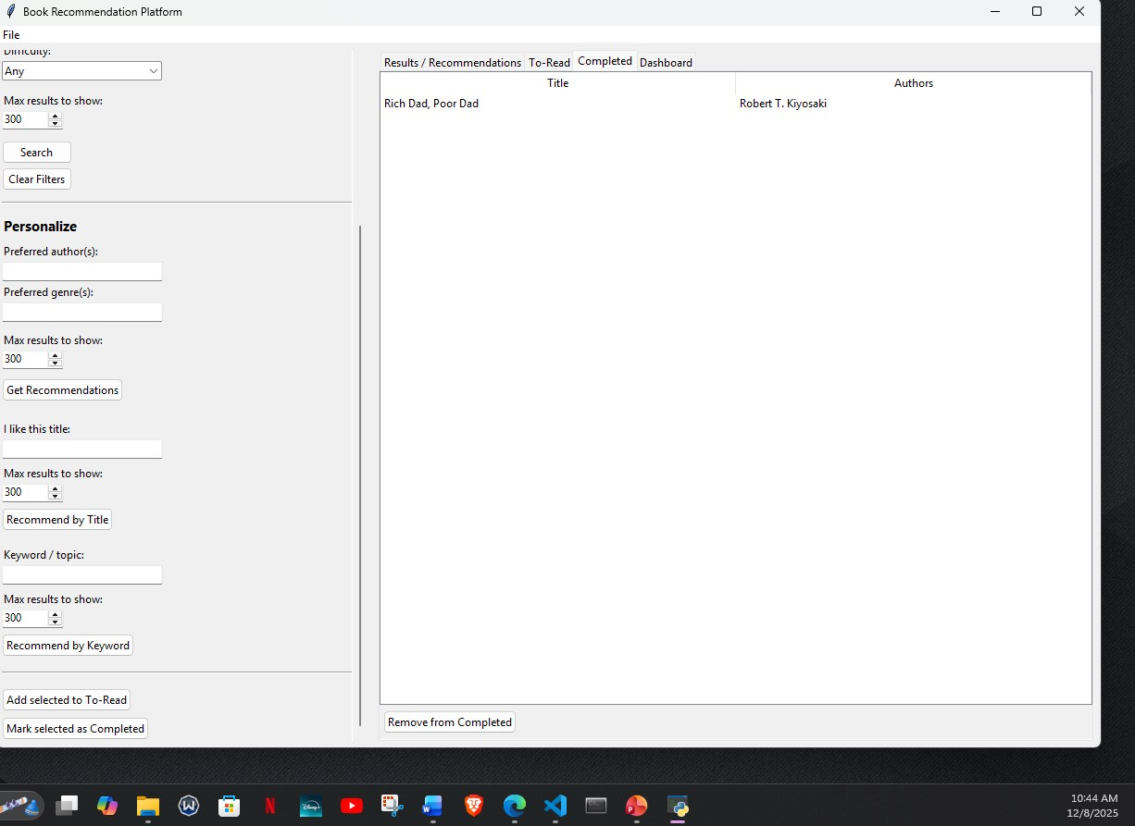
Figure 12.9

The following image (Figure 12.10) shows the dashboard containing the number of To-Read and Completed books progress.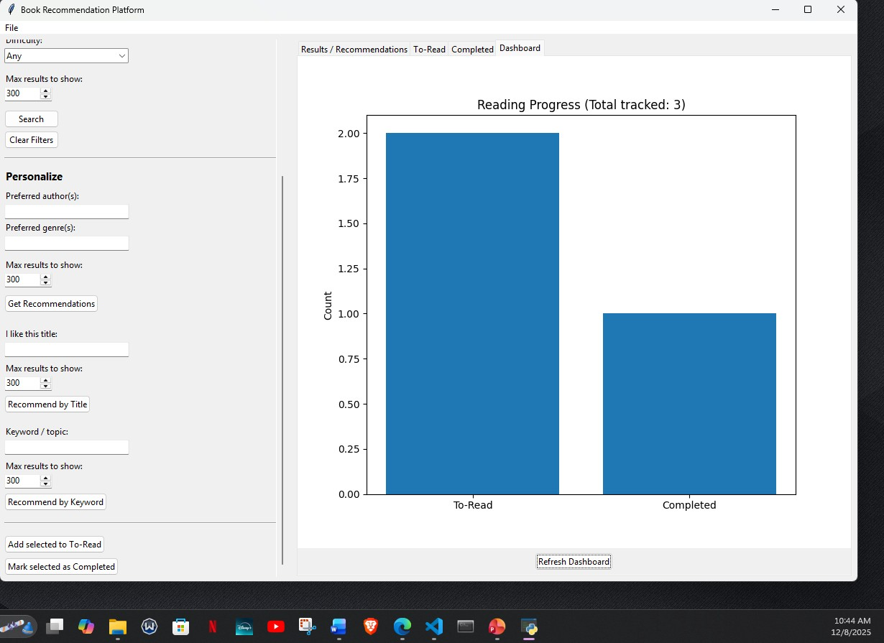
Figure 12.10

13. Issues to future studies
- Cold-start problem for new users
The current system has limited personalization for first-time users who have not yet built To-Read or Completed lists, so future work could explore onboarding surveys or default personas to improve early recommendations.
- Dependence on a static offline dataset
Recommendations are restricted to whatever is in the local CSV, so future studies could integrate live APIs (e.g., Google Books/Goodreads) to keep the catalog fresh and automatically updated.
- Limited evaluation with real readers
The system has not yet been tested with a large group of real users, so structured usability studies and A/B tests are needed to validate recommendation quality and UI design.
- Simple TF-IDF similarity model
The current content-based engine uses TF-IDF and cosine similarity only, and future research could compare this with deep learning embeddings or hybrid (content + collaborative) recommenders.
- No explicit handling of reading time or goals
The platform does not consider reading speed or time constraints, so future work could add features that recommend books based on estimated reading time and user goals (e.g., “finish 2 books per month”).
- Basic difficulty and genre modeling
Difficulty and genre are treated as simple filters, so more advanced modeling (e.g., multi-label genre embeddings or finer-grained difficulty levels) could make recommendations more nuanced.
- Lack of explainable recommendations
The system does not show why a book was recommended, so future studies could add explanation features (e.g., “similar author,” “same genre,” “matches your favorite topics”) to improve transparency and trust.
- Single-user desktop deployment
The application currently runs as a standalone desktop tool, and future work could investigate a multi-user web or mobile version with shared profiles and cloud-based storage.
- No support for multilingual or cross-language recommendations
Although language is a filter, there is no cross-language recommendation logic, so future research could explore suggesting translated works or bridging users between languages they read.
- Limited analytics on reading behavior
The system only tracks To-Read and Completed counts, so future studies could add richer analytics (session length, abandonment rates, genre drift) to better understand and adapt to user reading patterns.

14. Conclusion
In conclusion, this project demonstrates that a focused, desktop Book Recommendation Platform can meaningfully reduce the effort a reader spends choosing their next book by combining a clean Tkinter GUI with a TF-IDF–based recommendation engine and persistent reading lists. By loading an enriched books_enriched.csv dataset into the BookData model, mapping columns, and exposing search and recommendation methods through BookApp, the system supports practical tasks such as filtering by title, author, language, genre, and difficulty, generating content-based suggestions, and saving titles to To-Read and Completed lists that are stored in JSON and visualized in a simple progress dashboard. The analysis and design work—use case, class, object, sequence, statechart, deployment, package, and ER diagrams—helped ensure that the implementation stayed aligned with the original requirements, while unit, module, integration, and functional tests all passing provided confidence that core logic and key user workflows behave correctly. At the same time, the work also highlighted several opportunities for future improvement, including richer personalization for new users, more advanced recommendation models, live catalog updates, and expanded analytics, which together offer a clear roadmap for extending this platform into a more sophisticated reading companion in future studies.

15. References
Graphical user interfaces with Tk. (n.d.). Python Documentation. https://docs.python.org/3/library/tk.html?utm_source=chatgpt.com
pandas - Python Data Analysis Library. (n.d.). https://pandas.pydata.org/?utm_source=chatgpt.com
PlantUML Web Server. (n.d.). PlantUML.com. https://www.plantuml.com/
Python 3.14 documentation. (n.d.). Python Documentation. https://docs.python.org/3/

16. Appendix
Main Code
# Book Recommendation Platform

import json
import os
import re
import tkinter as tk
from tkinter import ttk, filedialog, messagebox
from typing import List, Optional, Dict

import pandas as pd
from sklearn.feature_extraction.text import TfidfVectorizer
from sklearn.metrics.pairwise import cosine_similarity

from matplotlib.figure import Figure
from matplotlib.backends.backend_tkagg import FigureCanvasTkAgg

# ========= YOUR DATASET PATH =========
# Deployment diagram: books_enriched.csv is the «artifact» stored in the
# user’s Windows file system. BookData.load_file() reads this file at runtime.
# ER diagram: each row corresponds to a Book plus related attributes
# (authors, genres, language_code, rating, difficulty, etc.).
# IMPORTANT: point to the enriched file you just downloaded
DATASET_PATH = r"C:\Users\lakshmi\Desktop\Homeworks\Fall 2025\Lakshmi Narayana Manukonda\Professional Seminar Riabov\Final Code\books_enriched.csv"
# ====================================

# APP_STATE_PATH is the JSON «artifact» shown in the deployment diagram
# (book_reco_state.json). It represents the AppState / ReadingListManager data.
APP_STATE_PATH = "book_reco_state.json"

def load_state() -> dict:
"""
Utility corresponding to the AppState.load_state() operation in the class diagram.
Sequence diagram (App launch): called as step 2 load_state().
It restores the 'to_read' and 'completed' lists that support
the Persist lists / Add selected to To-Read / Mark selected as completed use cases.
"""
if os.path.exists(APP_STATE_PATH):
try:
with open(APP_STATE_PATH, "r", encoding="utf-8") as f:
return json.load(f)
except Exception:
return {}
return {}

def save_state(state: dict):
"""
Utility corresponding to AppState.save_state() in the class diagram.
Sequence diagram (Updating lists): this function is invoked indirectly
from persist_lists() whenever the reading lists are updated, satisfying
the 'Persist lists' included use case.
"""
try:
with open(APP_STATE_PATH, "w", encoding="utf-8") as f:
json.dump(state, f, ensure_ascii=False, indent=2)
except Exception as e:
print("Failed to save state:", e)

def normalize_list_cell(x):
"""
Helper used by BookData.set_column_map() to normalize genre strings.
ER diagram: supports the many-to-many Book–Genre relationship by turning
a 'genre' string into a list of genre tokens.
"""
if pd.isna(x): return []
s = str(x).strip()
if not s: return []
if "|" in s:
return [p.strip() for p in s.split("|") if p.strip()]
if "," in s:
return [p.strip() for p in s.split(",") if p.strip()]
return [s]

# ---------- Scrollable Frame for the left sidebar ----------
class ScrollableFrame(ttk.Frame):
"""
UI helper component.
- Appears as a generic Frame in the class diagram (ttk.Frame / ScrollableFrame).
- In the UI mockup it provides the scrollable left panel with Search / Filters,
Personalize profile, and recommendation controls that implement the
corresponding use cases.
"""
def __init__(self, parent, *args, **kwargs):
super().__init__(parent, *args, **kwargs)
self.canvas = tk.Canvas(self, highlightthickness=0)
self.vsb = ttk.Scrollbar(self, orient="vertical", command=self.canvas.yview)
self.canvas.configure(yscrollcommand=self.vsb.set)

self.canvas.pack(side="left", fill="both", expand=True)
self.vsb.pack(side="right", fill="y")

self.inner = ttk.Frame(self.canvas)
self.inner_id = self.canvas.create_window((0, 0), window=self.inner, anchor="nw")

self.inner.bind("<Configure>", self._on_inner_configure)
self.canvas.bind("<Configure>", self._on_canvas_configure)

# Mouse wheel (Windows/Linux)
self.canvas.bind_all("<MouseWheel>", self._on_mousewheel)
self.canvas.bind_all("<Button-4>", self._on_mousewheel_linux)
self.canvas.bind_all("<Button-5>", self._on_mousewheel_linux)

def _on_inner_configure(self, event):
self.canvas.configure(scrollregion=self.canvas.bbox("all"))

def _on_canvas_configure(self, event):
self.canvas.itemconfigure(self.inner_id, width=event.width)

def _on_mousewheel(self, event):
self.canvas.yview_scroll(int(-1*(event.delta/120)), "units")

def _on_mousewheel_linux(self, event):
if event.num == 4:
self.canvas.yview_scroll(-1, "units")
elif event.num == 5:
self.canvas.yview_scroll(1, "units")

class BookData:
"""
Model / data-access class.
- Class diagram: corresponds to BookData + RecommendationEngine.
- ER diagram: wraps the Book, Author, Genre, Language data that come from
books_enriched.csv.
- Use-case support:
* Search books (search(), _apply_filters())
* Get recommendations / Recommend by title / Recommend by keyword
(recommend_for_profile, recommend_like_title, recommend_by_keyword)
* Set filters (get_languages/get_genres are used to populate filter choices).
- Sequence diagram:
* load_file() is step 8 load_file(DATASET_PATH)
* set_column_map() is step 10 set_column_map(mapping)
* TF-IDF vectorizer and matrix are steps 11–12 (fit_transform).
"""
def __init__(self):
self.df: Optional[pd.DataFrame] = None
self.feature_text: Optional[pd.Series] = None
self.vectorizer: Optional[TfidfVectorizer] = None
self.tfidf_matrix = None
# colmap maps logical attributes from class / ER diagrams to actual CSV columns.
# Example: 'title' → title/original_title, 'genres' → genre, etc.
self.colmap = {
"title": None, # required
"authors": None, # required
"genres": None, # optional (maps to 'genre')
"language": None, # optional (maps to 'language_code' if present)
"description": None, # optional
"rating": None, # optional (maps to 'average_rating' if present)
"difficulty": None # optional (maps to 'difficulty')
}

def load_file(self, path: str):
"""
Deployment / sequence diagram:
- Reads the dataset artifact (CSV/XLSX) from disk.
- This happens automatically during App launch (_auto_load_dataset) and
manually when user uses the File → Load dataset use-case.
"""
ext = os.path.splitext(path)[1].lower()
if ext in [".xlsx", ".xls"]:
df = pd.read_excel(path)
else:
df = pd.read_csv(path, encoding="utf-8", low_memory=False)
if df.empty:
raise ValueError("Empty dataset.")
self.df = df
return df

def set_column_map(self, mapping: Dict[str, Optional[str]]):
"""
Maps CSV columns into internal attributes, aligning data with the ER diagram:
- title/authors/genres/language_code/description/rating/difficulty.
Sequence diagram: called right after load_file() during dataset setup.
"""
for k in self.colmap:
self.colmap[k] = mapping.get(k) or None

for req in ["title", "authors"]:
if self.colmap[req] is None or self.colmap[req] not in self.df.columns:
raise ValueError(f"Column for '{req}' not set or not found.")

df = self.df.copy()

# Title + fallback
df["_title_main"] = df[self.colmap["title"]].astype(str)
if "original_title" in df.columns:
mask_blank = df["_title_main"].isna() | (df["_title_main"].str.strip() == "")
df.loc[mask_blank, "_title_main"] = df.loc[mask_blank, "original_title"].astype(str)

df["_authors"] = df[self.colmap["authors"]].astype(str).fillna("")

# Genres
if self.colmap["genres"] and self.colmap["genres"] in df.columns:
df["_genres_list"] = df[self.colmap["genres"]].apply(normalize_list_cell)
df["_genres"] = df["_genres_list"].apply(lambda xs: " ".join([g.replace(" ", "_") for g in xs]))
else:
df["_genres_list"] = [[] for _ in range(len(df))]
df["_genres"] = ""

# Language (or fallback)
if self.colmap["language"] and self.colmap["language"] in df.columns:
df["_language"] = df[self.colmap["language"]].astype(str).fillna("")
else:
if "language_code" in df.columns:
df["_language"] = df["language_code"].astype(str).fillna("")
else:
df["_language"] = ""

# Description
if self.colmap["description"] and self.colmap["description"] in df.columns:
df["_description"] = df[self.colmap["description"]].astype(str).fillna("")
else:
df["_description"] = ""

# Rating
if self.colmap["rating"] and self.colmap["rating"] in df.columns:
df["_rating"] = pd.to_numeric(df[self.colmap["rating"]], errors="coerce")
else:
df["_rating"] = pd.NA

# Difficulty
if self.colmap["difficulty"] and self.colmap["difficulty"] in df.columns:
df["_difficulty"] = df[self.colmap["difficulty"]].astype(str)
else:
df["_difficulty"] = pd.NA

# Text features for TF-IDF
# Keep description in the mix so semantic similarity still works when strict match is empty
# Class diagram: this is the RecommendationEngine.tf() / transform() responsibility.
self.feature_text = (
df["_title_main"].str.lower().fillna("") + " " +
df["_authors"].str.lower().str.replace(r"\s+", "_", regex=True).fillna("") + " " +
df["_genres"].str.lower().fillna("") + " " +
df["_description"].str.lower().fillna("")
)

self.df = df.reset_index(drop=True)
self.vectorizer = TfidfVectorizer(
lowercase=True, stop_words="english",
max_features=50000, ngram_range=(1, 2)
)
# Sequence diagram steps 11–12: fit_transform(feature_text) builds tfidf_matrix.
self.tfidf_matrix = self.vectorizer.fit_transform(self.feature_text.fillna(""))

def get_languages(self) -> List[str]:
"""
Returns distinct language codes to populate the 'Language' filter combobox.
Use-case diagram: supports Set filters for Search books / Get recommendations.
"""
if self.df is None: return []
langs = [x for x in self.df["_language"].dropna().astype(str).unique() if x]
return sorted(langs) if langs else ["Any"]

def get_genres(self) -> List[str]:
"""
Returns distinct genres to populate the 'Genre' filter combobox.
Connects to the Genre entity in the ER diagram.
"""
if self.df is None: return []
all_g = set()
for xs in self.df["_genres_list"]:
for g in xs:
if g:
all_g.add(g)
return sorted(all_g)

def _apply_filters(self, df: pd.DataFrame, title_kw: str, author_kw: str,
language: str, genre: str, difficulty: str) -> pd.DataFrame:
"""
Core filtering logic.
- Implements the Set filters use case for both Search and recommendation flows.
- Statechart: this is part of the 'Searching' / 'Recommending' internal behavior.
"""
m = pd.Series(True, index=df.index)
if title_kw:
m &= df["_title_main"].str.contains(title_kw, case=False, na=False)
if author_kw:
m &= df["_authors"].str.contains(author_kw, case=False, na=False)
if language and language != "Any":
m &= df["_language"].str.lower().eq(language.lower())
if genre and genre != "Any":
m &= df["_genres_list"].apply(lambda xs: genre in xs if isinstance(xs, list) else False)
if difficulty and difficulty != "Any":
m &= df["_difficulty"].fillna("").str.lower().eq(difficulty.lower())
return df.loc[m].copy()

def search(self, title_kw: str, author_kw: str, language: str, genre: str, difficulty: str) -> pd.DataFrame:
"""
Use-case: Search books.
Sequence diagram (User triggers Search): called at step 16 search(...),
after the user clicks the Search button in BookApp.on_search().
"""
df = self._apply_filters(self.df, title_kw, author_kw, language, genre, difficulty)
out = df.loc[:, ["_title_main", "_authors", "_language", "_rating", "_difficulty"]].copy()
out.rename(columns={"_title_main": "title", "_authors": "authors", "_language": "language",
"_rating": "rating", "_difficulty": "difficulty"}, inplace=True)
return out

# ---- similarity helpers ----
def _strict_desc_subset(self, base: pd.DataFrame, query: str) -> pd.DataFrame:
"""
Helper that narrows down candidates to rows whose description contains tokens
from the user's query. Used by recommendation methods to better match topics.
"""
tokens = [t.strip() for t in re.split(r"[,\s]+", query) if t.strip()]
if not tokens:
return base.iloc[0:0]
pat = "|".join(re.escape(t) for t in tokens)
mask = base["_description"].str.contains(pat, case=False, na=False)
return base.loc[mask].copy()

def recommend_for_profile(self, profile_query: str, k: int = 20,
allow_language: Optional[str] = None,
genre_filter: Optional[str] = None,
difficulty: Optional[str] = None,
title_kw: str = "", author_kw: str = "") -> pd.DataFrame:
"""
Use-case: Personalize profile + Get recommendations.
- Takes user preferences for author/genre (from BookApp UI) and returns
a ranked list of books using cosine similarity.
- In the sequence diagram this is part of the 'Recommending' path
(similar to search(), but using TF-IDF instead of simple filters only).
"""
if not profile_query.strip():
return pd.DataFrame()
base = self._apply_filters(self.df, title_kw, author_kw,
allow_language or "Any",
genre_filter or "Any",
difficulty or "Any")
if base.empty:
return pd.DataFrame()

vec = self.vectorizer.transform([profile_query.lower()])
sims = cosine_similarity(self.tfidf_matrix[base.index], vec).ravel()
base = base.copy()
base["score"] = sims
base = base.sort_values("score", ascending=False).head(k)
return base[["_title_main", "_authors", "_language", "_rating", "_difficulty", "score"]].rename(
columns={"_title_main": "title", "_authors": "authors", "_language": "language",
"_rating": "rating", "_difficulty": "difficulty"}
)

def recommend_like_title(self, like_title: str, k: int = 20,
allow_language: Optional[str] = None,
genre_filter: Optional[str] = None,
difficulty: Optional[str] = None,
title_kw: str = "", author_kw: str = "") -> pd.DataFrame:
"""
Use-case: Recommend by title.
- User provides a known book title; method returns similar books.
- In the use-case diagram this is a separate oval but internally reuses the
same RecommendationEngine (TF-IDF + cosine similarity).
"""
if not like_title.strip():
return pd.DataFrame()

base = self._apply_filters(self.df, title_kw, author_kw,
allow_language or "Any",
genre_filter or "Any",
difficulty or "Any")
if base.empty:
return pd.DataFrame()

# First try strict description match using the title text (helps steer to true topic)
strict = self._strict_desc_subset(base, like_title)
pool = strict if not strict.empty else base

# Find a good anchor vector
t_norm = like_title.strip().casefold()
exact_idx = pool.index[pool["_title_main"].str.casefold() == t_norm]
if len(exact_idx) == 0:
contains_idx = self.df.index[self.df["_title_main"].str.contains(re.escape(like_title), case=False, na=False)]
anchor_idx = contains_idx[0] if len(contains_idx) else None
else:
anchor_idx = exact_idx[0]

anchor_vec = self.tfidf_matrix[anchor_idx] if anchor_idx is not None else self.vectorizer.transform([like_title.lower()])

sims = cosine_similarity(self.tfidf_matrix[pool.index], anchor_vec).ravel()
res = pool.copy()
res["score"] = sims
res = res[res["_title_main"].str.casefold() != t_norm]
res = res.sort_values("score", ascending=False).head(k)
return res[["_title_main", "_authors", "_language", "_rating", "_difficulty", "score"]].rename(
columns={"_title_main": "title", "_authors": "authors", "_language": "language",
"_rating": "rating", "_difficulty": "difficulty"}
)

def recommend_by_keyword(self, keyword_query: str, k: int = 20,
allow_language: Optional[str] = None,
genre_filter: Optional[str] = None,
difficulty: Optional[str] = None,
title_kw: str = "", author_kw: str = "") -> pd.DataFrame:
"""
Use-case: Recommend by keyword.
- Keyword/topic comes from the UI ('Keyword / topic' text field).
- This again uses TF-IDF similarity over filtered candidates.
"""
if not keyword_query.strip():
return pd.DataFrame()
base = self._apply_filters(self.df, title_kw, author_kw,
allow_language or "Any",
genre_filter or "Any",
difficulty or "Any")
if base.empty:
return pd.DataFrame()

# STRICT pass: require that description contains ANY of the tokens
strict = self._strict_desc_subset(base, keyword_query)
pool = strict if not strict.empty else base

qvec = self.vectorizer.transform([keyword_query.lower()])
sims = cosine_similarity(self.tfidf_matrix[pool.index], qvec).ravel()
res = pool.copy()
res["score"] = sims
res = res.sort_values("score", ascending=False).head(k)
return res[["_title_main", "_authors", "_language", "_rating", "_difficulty", "score"]].rename(
columns={"_title_main": "title", "_authors": "authors", "_language": "language",
"_rating": "rating", "_difficulty": "difficulty"}
)

class BookApp(tk.Tk):
"""
Main application / controller class.
- In the class diagram, BookApp composes BookData and uses AppState / ReadingListManager.
- Statechart diagram:
* Launching → Idle → Searching / Recommending / UpdatingLists.
The event handlers below (on_search, on_recommend, etc.) correspond to those transitions.
- Deployment diagram: BookApp is the «application» running inside the Python 3.x
runtime on a Windows PC.
- Use-case mapping:
* Search / filters / Clear results
* Personalize profile / Get recommendations / Recommend by title / keyword
* Manage To-Read / Completed lists
* Refresh dashboard / View progress chart
* Persist lists via AppState JSON.
"""
def __init__(self):
super().__init__()
self.title("Book Recommendation Platform")
self.geometry("1180x760")

# Sequence diagram step 2: load_state()
self.state = load_state()
# Composition: BookApp owns one BookData instance (class diagram).
self.data = BookData()

# These lists implement the ReadingListManager responsibilities in the
# class diagram and support use cases:
# - Add selected to To-Read
# - Mark selected as completed
# - Remove from To-Read / Completed
self.to_read: List[str] = self.state.get("to_read", [])
self.completed: List[str] = self.state.get("completed", [])

# One shared IntVar used by all spinboxes (kept in sync)
# This supports the “Max results to show” UI feature in several use cases.
self.max_results_var = tk.IntVar(value=300)

# Build menus and layout (sequence diagram step 5 build_menu/build_layout).
self._build_menu()
self._build_layout()
# Auto-load dataset (sequence diagram: Auto-load dataset lifeline).
self._auto_load_dataset()

def _build_menu(self):
"""
Menu bar with 'Load dataset' and 'Exit'.
- Implements the File → Load dataset use case from the non-functional requirements.
- Also appears as part of BookApp UI in the deployment and UI mockup.
"""
menubar = tk.Menu(self)
filem = tk.Menu(menubar, tearoff=0)
filem.add_command(label="Load dataset (CSV/XLSX)...", command=self.on_load_dataset)
filem.add_separator()
filem.add_command(label="Exit", command=self.destroy)
menubar.add_cascade(label="File", menu=filem)
self.config(menu=menubar)

def _build_layout(self):
"""
Builds the UI layout exactly as shown in the draft user interface:
- Left: scrollable panel with filters and recommendation controls
- Right: notebook with Results, To-Read, Completed, Dashboard tabs
This layout directly realizes the use-case diagram interactions:
Search books, Set/Clear filters, Personalize profile, Get recommendations,
Recommend by title/keyword, manage lists, and view dashboard.
"""
# Left: scrollable sidebar
left_wrap = ScrollableFrame(self)
left_wrap.pack(side=tk.LEFT, fill=tk.Y, padx=6, pady=6)
left = left_wrap.inner

# --- Search / Filters ---
# Use-case: Search books / Set filters.
ttk.Label(left, text="Search / Filters", font=("Segoe UI", 11, "bold")).pack(anchor="w", pady=(0,6))
self.title_var = tk.StringVar()
self.author_var = tk.StringVar()
self.lang_var = tk.StringVar(value="Any")
self.genre_var = tk.StringVar(value="Any")
self.diff_var = tk.StringVar(value="Any")

ttk.Label(left, text="Title contains:").pack(anchor="w")
ttk.Entry(left, textvariable=self.title_var, width=28).pack(anchor="w", pady=2)

ttk.Label(left, text="Author contains:").pack(anchor="w", pady=(8,0))
ttk.Entry(left, textvariable=self.author_var, width=28).pack(anchor="w", pady=2)

ttk.Label(left, text="Language:").pack(anchor="w", pady=(8,0))
self.lang_cb = ttk.Combobox(left, textvariable=self.lang_var, width=25, state="readonly", values=["Any"])
self.lang_cb.pack(anchor="w", pady=2)

ttk.Label(left, text="Genre:").pack(anchor="w", pady=(8,0))
self.genre_cb = ttk.Combobox(left, textvariable=self.genre_var, width=25, state="readonly", values=["Any"])
self.genre_cb.pack(anchor="w", pady=2)

ttk.Label(left, text="Difficulty:").pack(anchor="w", pady=(8,0))
self.diff_cb = ttk.Combobox(left, textvariable=self.diff_var, width=25, state="readonly",
values=["Any","Beginner","Intermediate","Advanced"])
self.diff_cb.pack(anchor="w", pady=2)

# Max results (Search/Filters section)
ttk.Label(left, text="Max results to show:").pack(anchor="w", pady=(10,0))
ttk.Spinbox(left, from_=10, to=2000, increment=10, textvariable=self.max_results_var, width=8).pack(anchor="w", pady=2)

# Statechart: clicking Search moves Idle → Searching.
ttk.Button(left, text="Search", command=self.on_search).pack(anchor="w", pady=(10,4))
# Use-case: Clear filters / Clear results.
ttk.Button(left, text="Clear Filters", command=self.on_clear_filters).pack(anchor="w")

ttk.Separator(left, orient="horizontal").pack(fill="x", pady=12)

# --- Personalize ---
# Use-case: Personalize profile (author/genre preferences) and Get recommendations.
ttk.Label(left, text="Personalize", font=("Segoe UI", 11, "bold")).pack(anchor="w", pady=(0,6))
self.pref_author = tk.StringVar()
self.pref_genre = tk.StringVar()
ttk.Label(left, text="Preferred author(s):").pack(anchor="w")
ttk.Entry(left, textvariable=self.pref_author, width=28).pack(anchor="w", pady=2)
ttk.Label(left, text="Preferred genre(s):").pack(anchor="w")
ttk.Entry(left, textvariable=self.pref_genre, width=28).pack(anchor="w", pady=2)

# Max results (Personalize section)
ttk.Label(left, text="Max results to show:").pack(anchor="w", pady=(8,0))
ttk.Spinbox(left, from_=10, to=2000, increment=10, textvariable=self.max_results_var, width=8).pack(anchor="w", pady=2)

ttk.Button(left, text="Get Recommendations", command=self.on_recommend).pack(anchor="w", pady=8)

# --- Recommend by Title ---
# Use-case: Recommend by title.
ttk.Label(left, text="I like this title:").pack(anchor="w", pady=(12,0))
self.like_title_var = tk.StringVar()
ttk.Entry(left, textvariable=self.like_title_var, width=28).pack(anchor="w", pady=2)

# Max results (Title section)
ttk.Label(left, text="Max results to show:").pack(anchor="w", pady=(4,0))
ttk.Spinbox(left, from_=10, to=2000, increment=10, textvariable=self.max_results_var, width=8).pack(anchor="w", pady=2)

ttk.Button(left, text="Recommend by Title", command=self.on_recommend_by_title).pack(anchor="w", pady=4)

# --- Recommend by Keyword ---
# Use-case: Recommend by keyword.
ttk.Label(left, text="Keyword / topic:").pack(anchor="w", pady=(12,0))
self.keyword_var = tk.StringVar()
ttk.Entry(left, textvariable=self.keyword_var, width=28).pack(anchor="w", pady=2)

# Max results (Keyword section)
ttk.Label(left, text="Max results to show:").pack(anchor="w", pady=(4,0))
ttk.Spinbox(left, from_=10, to=2000, increment=10, textvariable=self.max_results_var, width=8).pack(anchor="w", pady=2)

ttk.Button(left, text="Recommend by Keyword", command=self.on_recommend_by_keyword).pack(anchor="w", pady=4)

ttk.Separator(left, orient="horizontal").pack(fill="x", pady=12)

# List management buttons implement:
# - Add selected to To-Read
# - Mark selected as completed
ttk.Button(left, text="Add selected to To-Read", command=self.add_selected_to_read).pack(anchor="w", pady=4)
ttk.Button(left, text="Mark selected as Completed", command=self.add_selected_completed).pack(anchor="w", pady=2)

# Right: notebook with scrollable results + other tabs
right = ttk.Notebook(self)
right.pack(side=tk.LEFT, fill=tk.BOTH, expand=True, padx=6, pady=6)

self.tab_results = ttk.Frame(right)
self.tab_toread = ttk.Frame(right)
self.tab_completed = ttk.Frame(right)
self.tab_dashboard = ttk.Frame(right)

right.add(self.tab_results, text="Results / Recommendations")
right.add(self.tab_toread, text="To-Read")
right.add(self.tab_completed, text="Completed")
right.add(self.tab_dashboard, text="Dashboard")

self._build_results_tab(self.tab_results)
self._build_to_read_tab()
self._build_completed_tab()
self._build_dashboard_tab()

def _build_results_tab(self, parent):
"""
Builds the main results grid.
- Use-case: Search books / Get recommendations.
- Users can 'Select row in results' here before adding to lists, as shown in
the use-case diagram.
"""
container = ttk.Frame(parent)
container.pack(fill=tk.BOTH, expand=True)

cols = ("title","authors","language","rating","difficulty","score")
self.tree = ttk.Treeview(container, columns=cols, show="headings")

# Scrollbars
vsb = ttk.Scrollbar(container, orient="vertical", command=self.tree.yview)
hsb = ttk.Scrollbar(container, orient="horizontal", command=self.tree.xview)
self.tree.configure(yscrollcommand=vsb.set, xscrollcommand=hsb.set)

for c in cols:
self.tree.heading(c, text=c.title())
w = 260 if c in ("title","authors") else 110 if c == "language" else 90
self.tree.column(c, width=w, anchor="w")

self.tree.grid(row=0, column=0, sticky="nsew")
vsb.grid(row=0, column=1, sticky="ns")
hsb.grid(row=1, column=0, sticky="ew")
container.rowconfigure(0, weight=1)
container.columnconfigure(0, weight=1)

bottom = ttk.Frame(parent)
bottom.pack(fill="x", pady=6)
# Use-case: Clear results.
ttk.Button(bottom, text="Clear Results", command=self.clear_results).pack(side=tk.LEFT)
ttk.Label(parent, text="Tip: Click a row, then use the buttons on the left to add to lists.").pack(anchor="w", pady=4)

def clear_results(self):
"""Implements the 'Clear results' use case from the use-case diagram."""
for tr in self.tree.get_children():
self.tree.delete(tr)

def _build_to_read_tab(self):
"""
Tab backing the 'To-Read' list.
- Corresponds to ReadingListManager.to_read in the class diagram and the
ReadingListItem entity in the ER diagram (status = To-Read).
"""
self.tree_tr = ttk.Treeview(self.tab_toread, columns=("title","authors"), show="headings")
for c in ("title","authors"):
self.tree_tr.heading(c, text=c.title())
self.tree_tr.column(c, width=420, anchor="w")
self.tree_tr.pack(fill=tk.BOTH, expand=True)
btns = ttk.Frame(self.tab_toread)
btns.pack(fill="x", pady=6)
# Use-case: Remove from To-Read.
ttk.Button(btns, text="Remove from To-Read", command=self.remove_from_to_read).pack(side=tk.LEFT, padx=4)

def _build_completed_tab(self):
"""
Tab backing the 'Completed' list.
- Corresponds to ReadingListItem with status = Completed in the ER diagram.
"""
self.tree_c = ttk.Treeview(self.tab_completed, columns=("title","authors"), show="headings")
for c in ("title","authors"):
self.tree_c.heading(c, text=c.title())
self.tree_c.column(c, width=420, anchor="w")
self.tree_c.pack(fill=tk.BOTH, expand=True)
btns = ttk.Frame(self.tab_completed)
btns.pack(fill="x", pady=6)
# Use-case: Remove from completed.
ttk.Button(btns, text="Remove from Completed", command=self.remove_from_completed).pack(side=tk.LEFT, padx=4)

def _build_dashboard_tab(self):
"""
Dashboard tab that shows the reading progress bar chart.
- Use-case: Refresh dashboard / View progress chart (included use case).
- Class diagram: uses matplotlib.figure.Figure / FigureCanvasTkAgg external types.
"""
self.fig = Figure(figsize=(5,3), dpi=100)
self.ax1 = self.fig.add_subplot(111)
self.canvas = FigureCanvasTkAgg(self.fig, master=self.tab_dashboard)
self.canvas.get_tk_widget().pack(fill=tk.BOTH, expand=True)
ttk.Button(self.tab_dashboard, text="Refresh Dashboard", command=self.refresh_dashboard).pack(pady=6)

# ---------- Dataset loading ----------
def _auto_load_dataset(self):
"""
Implements the 'Auto-load dataset' fragment from the sequence diagram.
- Checks for books_enriched.csv at startup.
- If present, calls BookData.load_file() and BookData.set_column_map().
- When done, it transitions the statechart from Launching → Idle.
"""
if not os.path.exists(DATASET_PATH):
messagebox.showwarning("Dataset not found",
f"Could not find dataset at:\n{DATASET_PATH}\n\nUse File → Load dataset to pick your CSV/XLSX.")
return
try:
df = self.data.load_file(DATASET_PATH)
except Exception as e:
messagebox.showerror("Load failed", str(e))
return

mapping = {
"title": "title" if "title" in df.columns else ("original_title" if "original_title" in df.columns else None),
"authors": "authors" if "authors" in df.columns else None,
"genres": "genre" if "genre" in df.columns else None,
"language": "language_code" if "language_code" in df.columns else None,
"description": "description" if "description" in df.columns else None,
"rating": "average_rating" if "average_rating" in df.columns else None,
"difficulty": "difficulty" if "difficulty" in df.columns else None
}
try:
self.data.set_column_map(mapping)
except Exception as e:
messagebox.showerror("Mapping error", f"{e}\n\nOpen File → Load dataset and map manually.")
return

self._populate_filters()
messagebox.showinfo("Dataset ready",
f"Loaded and indexed:\n{DATASET_PATH}\n\nYou can now Search or Get Recommendations.")

def on_load_dataset(self):
"""
Handler for File → Load dataset menu command.
- Supports the non-functional requirement of allowing users to swap datasets.
- Follows the same mapping / indexing sequence as _auto_load_dataset().
"""
path = filedialog.askopenfilename(
title="Select books dataset (CSV or Excel)",
filetypes=[("CSV","*.csv"),("Excel","*.xlsx *.xls"),("All files","*.*")]
)
if not path:
return
try:
df = self.data.load_file(path)
except Exception as e:
messagebox.showerror("Load failed", str(e))
return

mapping = {
"title": "title" if "title" in df.columns else ("original_title" if "original_title" in df.columns else None),
"authors": "authors" if "authors" in df.columns else None,
"genres": "genre" if "genre" in df.columns else None,
"language": "language_code" if "language_code" in df.columns else None,
"description": "description" if "description" in df.columns else None,
"rating": "average_rating" if "average_rating" in df.columns else None,
"difficulty": "difficulty" if "difficulty" in df.columns else None
}
try:
self.data.set_column_map(mapping)
except Exception:
# If automatic mapping fails, we invoke the mapping dialog (ask_column_map),
# corresponding to the manual mapping flow in the analysis models.
self.ask_column_map(df)
return

self._populate_filters()
messagebox.showinfo("Dataset ready", "Dataset loaded and indexed. You can now search or get recommendations.")

def _populate_filters(self):
"""
Uses BookData.get_languages() and get_genres() to populate filter options.
- Directly supports the 'Set filters' use case from the use-case diagram.
"""
langs = ["Any"] + self.data.get_languages()
self.lang_cb.configure(values=langs)
self.lang_var.set("Any")

genres = ["Any"] + (self.data.get_genres() or []
)
self.genre_cb.configure(values=genres if genres else ["Any"])
self.genre_var.set("Any")

def ask_column_map(self, df: pd.DataFrame):
"""
Shows a dialog that lets the user map columns manually.
- This UI corresponds to a refinement of the BookData.set_column_map() behavior
when automatic guessing is insufficient.
"""
top = tk.Toplevel(self)
top.title("Map Columns")
top.grab_set()
cols = ["(none)"] + list(df.columns)

mapping_vars = {}
frm = ttk.Frame(top, padding=10)
frm.pack(fill="both", expand=True)

ttk.Label(frm, text="Map your file's columns (only Title & Authors are required)").grid(row=0, column=0, columnspan=2, sticky="w", pady=(0,8))

fields = [
("title","Title *"),
("authors","Authors *"),
("genres","Genres (optional)"),
("language","Language (optional)"),
("description","Description (optional)"),
("rating","Rating (optional)"),
("difficulty","Difficulty (optional)")
]
for i,(key,label) in enumerate(fields, start=1):
ttk.Label(frm, text=label).grid(row=i, column=0, sticky="e", padx=(0,8), pady=3)
var = tk.StringVar(value="(none)")
cb = ttk.Combobox(frm, textvariable=var, values=cols, state="readonly", width=40)
if key == "genres":
guess = [c for c in df.columns if c.lower() == "genre"]
if guess: var.set(guess[0])
if key == "difficulty":
guess = [c for c in df.columns if c.lower() == "difficulty"]
if guess: var.set(guess[0])
if key == "description":
guess = [c for c in df.columns if c.lower() == "description"]
if guess: var.set(guess[0])
cb.grid(row=i, column=1, sticky="w", pady=3)
mapping_vars[key] = var

btns = ttk.Frame(frm)
btns.grid(row=len(fields)+1, column=0, columnspan=2, pady=(10,0))
ttk.Button(btns, text="Confirm", command=lambda: self._confirm_map(top, mapping_vars)).pack(side=tk.LEFT, padx=5)
ttk.Button(btns, text="Cancel", command=top.destroy).pack(side=tk.LEFT, padx=5)

def _confirm_map(self, dialog: tk.Toplevel, mapping_vars: Dict[str, tk.StringVar]):
"""
Callback for the mapping dialog.
- Builds a mapping dict and passes it to BookData.set_column_map().
- Once successful, filters are populated, completing the dataset-loading
workflow from the sequence diagram.
"""
mapping = {k:(v.get() if v.get()!="(none)" else None) for k,v in mapping_vars.items()}
try:
self.data.set_column_map(mapping)
except Exception as e:
messagebox.showerror("Mapping error", str(e))
return

self._populate_filters()
dialog.destroy()
messagebox.showinfo("Dataset ready", "Dataset loaded and indexed. You can now search or get recommendations.")

# ---------- Actions ----------
def on_search(self):
"""
Event handler for the Search button.
- Use-case: Search books.
- Statechart: Idle → Searching → Idle.
- Sequence diagram: corresponds to step 14 Click "Search", step 15 on_search(...),
step 16 BookData.search(...), step 18 DataFrame results, and step 19 _fill_tree().
"""
if self.data.df is None:
messagebox.showwarning("No dataset", "Load a dataset first (File → Load dataset).")
return
df = self.data.search(
self.title_var.get().strip(),
self.author_var.get().strip(),
self.lang_var.get(),
self.genre_var.get(),
self.diff_var.get()
)
df = df.head(max(1, int(self.max_results_var.get())))
self._fill_tree(df)

def on_clear_filters(self):
"""
Implements the Clear filters use case:
resets all filter fields and clears any results currently in the grid.
"""
self.title_var.set("")
self.author_var.set("")
self.lang_var.set("Any")
self.genre_var.set("Any")
self.diff_var.set("Any")
self.clear_results()

def on_recommend(self):
"""
Event handler for 'Get Recommendations'.
- Use-cases: Personalize profile + Get recommendations.
- Statechart: Idle → Recommending → Idle.
"""
if self.data.df is None:
messagebox.showwarning("No dataset", "Load a dataset first (File → Load dataset).")
return
profile = " ".join([
self.pref_author.get().strip(),
self.pref_genre.get().strip()
])
if not profile.strip():
messagebox.showinfo("Enter preferences", "Provide preferred author(s) and/or genre(s).")
return
recs = self.data.recommend_for_profile(
profile_query=profile,
k=max(1, int(self.max_results_var.get())),
allow_language=self.lang_var.get(),
genre_filter=self.genre_var.get(),
difficulty=self.diff_var.get(),
title_kw=self.title_var.get().strip(),
author_kw=self.author_var.get().strip()
)
self._fill_tree(recs)

def on_recommend_by_title(self):
"""
Event handler for 'Recommend by Title'.
- Use-case: Recommend by title.
"""
if self.data.df is None:
messagebox.showwarning("No dataset", "Load a dataset first (File → Load dataset).")
return
like_title = self.like_title_var.get().strip()
if not like_title:
messagebox.showinfo("Type a title", "Enter a title you like (e.g., Harry Potter).")
return
recs = self.data.recommend_like_title(
like_title=like_title,
k=max(1, int(self.max_results_var.get())),
allow_language=self.lang_var.get(),
genre_filter=self.genre_var.get(),
difficulty=self.diff_var.get(),
title_kw=self.title_var.get().strip(),
author_kw=self.author_var.get().strip()
)
if recs is None or recs.empty:
messagebox.showinfo("No results", "No similar titles found with current filters. Try relaxing filters (Genre/Language/Difficulty = Any).")
return
self._fill_tree(recs)

def on_recommend_by_keyword(self):
"""
Event handler for 'Recommend by Keyword'.
- Use-case: Recommend by keyword.
"""
if self.data.df is None:
messagebox.showwarning("No dataset", "Load a dataset first (File → Load dataset).")
return
q = self.keyword_var.get().strip()
if not q:
messagebox.showinfo("Type a keyword", "Enter a keyword or topic (e.g., money, investing, magic, wizard school).")
return
recs = self.data.recommend_by_keyword(
keyword_query=q,
k=max(1, int(self.max_results_var.get())),
allow_language=self.lang_var.get(),
genre_filter=self.genre_var.get(),
difficulty=self.diff_var.get(),
title_kw=self.title_var.get().strip(),
author_kw=self.author_var.get().strip()
)
if recs is None or recs.empty:
messagebox.showinfo("No results", "No matches for that keyword with current filters. Try relaxing Genre/Language/Difficulty or clear Title/Author contains.")
return
self._fill_tree(recs)

def _fill_tree(self, df: pd.DataFrame):
"""
Internal helper to show DataFrame results in the results treeview.
- Used by all searching / recommendation flows.
- After loading results, it refreshes reading lists and dashboard to keep
the UI consistent with the statechart (searching/recommending returns to Idle).
"""
self.clear_results()
if df is None or df.empty:
return
for _, r in df.iterrows():
row = (
r.get("title",""),
r.get("authors",""),
r.get("language",""),
"" if pd.isna(r.get("rating")) else r.get("rating"),
"" if pd.isna(r.get("difficulty")) else r.get("difficulty"),
"" if "score" not in r else f"{r['score']:.3f}"
)
self.tree.insert("", tk.END, values=row)

self.refresh_lists()
self.refresh_dashboard()

def get_selected_titles_from_results(self) -> List[str]:
"""
Helper to read the titles of currently selected rows in the Results tree.
- Use-case diagram: supports 'Select row in results' (precondition for
adding to To-Read or marking Completed).
"""
sel = []
for item in self.tree.selection():
vals = self.tree.item(item, "values")
if vals:
sel.append(vals[0])
return sel

def add_selected_to_read(self):
"""
Implements 'Add selected to To-Read' use case.
- Also triggers the Persist lists include-relationship by calling persist_lists().
- Statechart: Idle → UpdatingLists → Idle.
"""
titles = self.get_selected_titles_from_results()
if not titles:
return
for t in titles:
if t not in self.to_read and t not in self.completed:
self.to_read.append(t)
self.persist_lists()
self.refresh_lists()

def add_selected_completed(self):
"""
Implements 'Mark selected as completed' use case.
- Moves items from To-Read to Completed where appropriate.
"""
titles = self.get_selected_titles_from_results()
if not titles:
return
for t in titles:
if t in self.to_read:
self.to_read.remove(t)
if t not in self.completed:
self.completed.append(t)
self.persist_lists()
self.refresh_lists()

def remove_from_to_read(self):
"""
Implements 'Remove from To-Read' use case.
"""
items = self.tree_tr.selection()
for it in items:
vals = self.tree_tr.item(it, "values")
if vals and vals[0] in self.to_read:
self.to_read.remove(vals[0])
self.persist_lists()
self.refresh_lists()

def remove_from_completed(self):
"""
Implements 'Remove from completed' use case.
"""
items = self.tree_c.selection()
for it in items:
vals = self.tree_c.item(it, "values")
if vals and vals[0] in self.completed:
self.completed.remove(vals[0])
self.persist_lists()
self.refresh_lists()

def persist_lists(self):
"""
Persists To-Read and Completed lists via AppState JSON.
- Use-case diagram: corresponds to the 'Persist lists' included use case
used by all list-modifying operations.
- Class diagram: uses AppState.save_state().
"""
self.state["to_read"] = self.to_read
self.state["completed"] = self.completed
save_state(self.state)

def refresh_lists(self):
"""
Refreshes the To-Read and Completed tab views to reflect current state.
- This is part of the 'UpdatingLists' state in the statechart.
"""
for tr in self.tree_tr.get_children():
self.tree_tr.delete(tr)
for t in self.to_read:
a = ""
if self.data.df is not None:
m = self.data.df["_title_main"] == t
if m.any():
a = self.data.df.loc[m, "_authors"].iloc[0]
self.tree_tr.insert("", tk.END, values=(t, a))

for tr in self.tree_c.get_children():
self.tree_c.delete(tr)
for t in self.completed:
a = ""
if self.data.df is not None:
m = self.data.df["_title_main"] == t
if m.any():
a = self.data.df.loc[m, "_authors"].iloc[0]
self.tree_c.insert("", tk.END, values=(t, a))

def refresh_dashboard(self):
"""
Rebuilds the dashboard bar chart.
- Implements the 'Refresh dashboard' use case.
- Use-case diagram: this supports 'View progress chart'.
- Sequence diagram: corresponds to the 'Dashboard refresh' fragment
(steps 20–23).
"""
self.ax1.clear()
total = len(self.to_read) + len(self.completed)
values = [len(self.to_read), len(self.completed)]
if sum(values) == 0:
self.ax1.text(0.5, 0.5, "No data yet.\nAdd books to lists.",
ha="center", va="center", fontsize=12)
else:
self.ax1.bar(["To-Read","Completed"], values)
self.ax1.set_title(f"Reading Progress (Total tracked: {total})")
self.ax1.set_ylabel("Count")
self.canvas.draw()

if __name__ == "__main__":
# Entry point of the application.
# Sequence diagram: 'start app' (step 1) creates the BookApp object,
# which in turn creates BookData and loads AppState.
# Object diagram: this corresponds to the bookapp:BookApp instance
# owning data:BookData, state:dict, and having references to widgets.
app = BookApp()
app.mainloop()

Unit and Module Tests
# test_unit_module.py
import json
import os
from pathlib import Path

import pandas as pd
import pytest

import matplotlib
matplotlib.use("Agg") # headless-safe

import book_reco_app as app

# ---------- Fixtures ----------

@pytest.fixture
def temp_state_path(tmp_path, monkeypatch):
"""
Point APP_STATE_PATH to a temporary file so tests do not touch real disk state.
"""
path = tmp_path / "book_reco_state.json"
monkeypatch.setattr(app, "APP_STATE_PATH", str(path))
return path

@pytest.fixture
def sample_csv(tmp_path):
"""
Create a small sample books_enriched.csv–style file for tests.
"""
df = pd.DataFrame(
[
{
"title": "The Hobbit",
"original_title": "The Hobbit",
"authors": "J.R.R. Tolkien",
"genre": "Fantasy|Adventure",
"language_code": "en",
"description": "A fantasy adventure about a hobbit on a quest.",
"average_rating": 4.5,
"difficulty": "Intermediate",
},
{
"title": "Clean Code",
"original_title": "Clean Code",
"authors": "Robert C. Martin",
"genre": "Programming|Software",
"language_code": "en",
"description": "A book about writing clean, maintainable code.",
"average_rating": 4.2,
"difficulty": "Advanced",
},
{
"title": "Harry Potter and the Philosopher's Stone",
"original_title": "Harry Potter and the Philosopher's Stone",
"authors": "J.K. Rowling",
"genre": "Fantasy|Magic",
"language_code": "en",
"description": "A young wizard discovers his magical heritage.",
"average_rating": 4.7,
"difficulty": "Beginner",
},
]
)
path = tmp_path / "books_enriched.csv"
df.to_csv(path, index=False)
return str(path)

@pytest.fixture
def initialized_bookdata(sample_csv):
"""
BookData with df, colmap, feature_text, vectorizer and tfidf_matrix fully initialized.
"""
bd = app.BookData()
df = bd.load_file(sample_csv)
mapping = {
"title": "title",
"authors": "authors",
"genres": "genre",
"language": "language_code",
"description": "description",
"rating": "average_rating",
"difficulty": "difficulty",
}
bd.set_column_map(mapping)
assert bd.df is not None
assert bd.vectorizer is not None
assert bd.tfidf_matrix is not None
assert len(bd.feature_text) == len(df)
return bd

# =====================================================================
# UNIT TESTS
# =====================================================================

def test_ut_01_load_state_missing_file_returns_empty_dict(temp_state_path):
# APP_STATE_PATH points to non-existing file
if temp_state_path.exists():
temp_state_path.unlink()
state = app.load_state()
assert isinstance(state, dict)
assert state == {}

def test_ut_02_save_and_load_state_roundtrip(temp_state_path):
state_in = {"to_read": ["A"], "completed": ["B", "C"]}
app.save_state(state_in)
state_out = app.load_state()
assert state_out == state_in

def test_ut_03_normalize_list_cell_various_separators():
assert app.normalize_list_cell("Fantasy|Adventure") == ["Fantasy", "Adventure"]
assert app.normalize_list_cell("Drama, Mystery") == ["Drama", "Mystery"]
assert app.normalize_list_cell(None) == []
assert app.normalize_list_cell("") == []

def test_ut_04_bookdata_load_file_non_empty(sample_csv):
bd = app.BookData()
df = bd.load_file(sample_csv)
assert bd.df is not None
assert not df.empty

def test_ut_05_bookdata_set_column_map_creates_internal_columns(initialized_bookdata):
bd = initialized_bookdata
df = bd.df
for col in [
"_title_main",
"_authors",
"_genres_list",
"_genres",
"_language",
"_description",
"_rating",
"_difficulty",
]:
assert col in df.columns

def test_ut_06_bookdata_set_column_map_requires_title_and_authors(sample_csv):
bd = app.BookData()
bd.load_file(sample_csv)
bad_mapping = {
"title": "title",
"authors": None, # missing
"genres": "genre",
"language": "language_code",
"description": "description",
"rating": "average_rating",
"difficulty": "difficulty",
}
with pytest.raises(ValueError):
bd.set_column_map(bad_mapping)

def test_ut_07_get_languages_returns_sorted_unique(initialized_bookdata):
bd = initialized_bookdata
langs = bd.get_languages()
assert isinstance(langs, list)
assert "en" in langs

def test_ut_08_get_genres_returns_sorted_unique(initialized_bookdata):
bd = initialized_bookdata
genres = bd.get_genres()
# Expect Fantasy, Adventure, Programming, Software, Magic
assert "Fantasy" in genres
assert "Adventure" in genres
assert "Programming" in genres
assert "Magic" in genres
# No empty strings
assert "" not in genres

def test_ut_09_apply_filters_language_genre_difficulty(initialized_bookdata):
bd = initialized_bookdata
df = bd._apply_filters(
bd.df,
title_kw="",
author_kw="",
language="en",
genre="Fantasy",
difficulty="Beginner",
)
# Should match only the Harry Potter row
assert len(df) == 1
assert "Harry Potter" in df["_title_main"].iloc[0]

def test_ut_10_search_returns_expected_columns(initialized_bookdata):
bd = initialized_bookdata
df = bd.search("", "", "Any", "Any", "Any")
assert list(df.columns) == ["title", "authors", "language", "rating", "difficulty"]
assert len(df) == len(bd.df)

def test_ut_11_recommend_for_profile_returns_scored_results(initialized_bookdata):
bd = initialized_bookdata
recs = bd.recommend_for_profile("fantasy dragons", k=2)
assert len(recs) <= 2
assert "score" in recs.columns
if len(recs) >= 2:
# scores in descending order
assert recs["score"].iloc[0] >= recs["score"].iloc[1]

def test_ut_12_recommend_like_title_excludes_anchor(initialized_bookdata):
bd = initialized_bookdata
recs = bd.recommend_like_title("The Hobbit", k=5)
# The Hobbit should not be in the title column
assert not any("The Hobbit" == t for t in recs["title"].tolist())

# =====================================================================
# MODULE TESTS
# =====================================================================

def test_mt_01_bookdata_end_to_end_load_map_search(initialized_bookdata):
bd = initialized_bookdata
df = bd.search(title_kw="Harry", author_kw="", language="Any", genre="Any", difficulty="Any")
assert not df.empty
# Expect Harry Potter in results
assert any("Harry Potter" in t for t in df["title"].tolist())

def test_mt_02_bookdata_filter_by_difficulty(initialized_bookdata):
bd = initialized_bookdata
df = bd.search("", "", "Any", "Any", "Advanced")
# Should match only "Clean Code"
assert len(df) == 1
assert "Clean Code" in df["title"].iloc[0]

def test_mt_03_bookdata_profile_recommendations_pipeline(initialized_bookdata):
bd = initialized_bookdata
recs = bd.recommend_for_profile(
profile_query="fantasy magic",
k=5,
allow_language="Any",
genre_filter="Any",
difficulty="Any",
)
assert "title" in recs.columns
assert "score" in recs.columns

def test_mt_04_bookdata_keyword_recommendations_pipeline(initialized_bookdata):
bd = initialized_bookdata
recs = bd.recommend_by_keyword(
keyword_query="wizard",
k=5,
allow_language="Any",
genre_filter="Any",
difficulty="Any",
)
# Should favor Harry Potter, which mentions wizard
titles = recs["title"].tolist()
assert any("Harry Potter" in t for t in titles)

def test_mt_05_appstate_persistence_module(temp_state_path):
state = {"to_read": ["Book A", "Book B"], "completed": ["Book C"]}
app.save_state(state)
loaded = app.load_state()
assert loaded == state

def test_mt_06_bookapp_list_management_module(initialized_bookdata, tmp_path, monkeypatch):
# Point APP_STATE_PATH to temp
state_path = tmp_path / "book_reco_state.json"
monkeypatch.setattr(app, "APP_STATE_PATH", str(state_path))

# Avoid actual Tk messageboxes during tests
monkeypatch.setattr(app.messagebox, "showinfo", lambda *a, **k: None)
monkeypatch.setattr(app.messagebox, "showwarning", lambda *a, **k: None)
monkeypatch.setattr(app.messagebox, "showerror", lambda *a, **k: None)

# Point DATASET_PATH to our sample CSV
# (BookApp will call _auto_load_dataset in __init__)
csv_path = tmp_path / "books_enriched.csv"
initialized_bookdata.df.to_csv(csv_path, index=False)
monkeypatch.setattr(app, "DATASET_PATH", str(csv_path))

# Create BookApp instance (no mainloop)
book_app = app.BookApp()

# Insert a fake result row
book_app.tree.insert("", "end", values=("Test Book", "Some Author", "en", 4.0, "Beginner", ""))

# Select it and add to To-Read
item_id = book_app.tree.get_children()[0]
book_app.tree.selection_set(item_id)
book_app.add_selected_to_read()

assert "Test Book" in book_app.to_read
assert "Test Book" not in book_app.completed

# Mark as completed
book_app.add_selected_completed()
assert "Test Book" in book_app.completed
assert "Test Book" not in book_app.to_read

book_app.destroy()

def test_mt_07_dashboard_bar_chart_module(initialized_bookdata, tmp_path, monkeypatch):
# Minimal BookApp with fake lists
state_path = tmp_path / "book_reco_state.json"
monkeypatch.setattr(app, "APP_STATE_PATH", str(state_path))

monkeypatch.setattr(app.messagebox, "showinfo", lambda *a, **k: None)
monkeypatch.setattr(app.messagebox, "showwarning", lambda *a, **k: None)
monkeypatch.setattr(app.messagebox, "showerror", lambda *a, **k: None)

csv_path = tmp_path / "books_enriched.csv"
initialized_bookdata.df.to_csv(csv_path, index=False)
monkeypatch.setattr(app, "DATASET_PATH", str(csv_path))

book_app = app.BookApp()
book_app.to_read = ["A", "B", "C"]
book_app.completed = ["D"]

# Should not raise any exception
book_app.refresh_dashboard()
assert book_app.ax1 is not None
book_app.destroy()

def test_mt_08_max_results_limit_module(initialized_bookdata):
bd = initialized_bookdata
# Ask for 1 result only
recs = bd.recommend_for_profile("fantasy", k=1)
assert len(recs) <= 1

def test_mt_09_recommendations_handle_empty_profile(initialized_bookdata):
bd = initialized_bookdata
recs = bd.recommend_for_profile("", k=5)
assert recs.empty

def test_mt_10_keyword_recommendations_handle_empty_query(initialized_bookdata):
bd = initialized_bookdata
recs = bd.recommend_by_keyword("", k=5)
assert recs.empty

Integration Tests
# test_integration.py
import json
from pathlib import Path

import pandas as pd
import pytest

import matplotlib
matplotlib.use("Agg")

import book_reco_app as app

@pytest.fixture
def sample_csv(tmp_path):
df = pd.DataFrame(
[
{
"title": "The Hobbit",
"original_title": "The Hobbit",
"authors": "J.R.R. Tolkien",
"genre": "Fantasy|Adventure",
"language_code": "en",
"description": "A fantasy adventure about a hobbit.",
"average_rating": 4.5,
"difficulty": "Intermediate",
},
{
"title": "Clean Code",
"original_title": "Clean Code",
"authors": "Robert C. Martin",
"genre": "Programming|Software",
"language_code": "en",
"description": "Clean, maintainable coding practices.",
"average_rating": 4.2,
"difficulty": "Advanced",
},
]
)
path = tmp_path / "books_enriched.csv"
df.to_csv(path, index=False)
return str(path)

@pytest.fixture
def basic_app(tmp_path, sample_csv, monkeypatch):
# Redirect APP_STATE_PATH and DATASET_PATH
state_path = tmp_path / "book_reco_state.json"
monkeypatch.setattr(app, "APP_STATE_PATH", str(state_path))
monkeypatch.setattr(app, "DATASET_PATH", sample_csv)

# No GUI popups
monkeypatch.setattr(app.messagebox, "showinfo", lambda *a, **k: None)
monkeypatch.setattr(app.messagebox, "showwarning", lambda *a, **k: None)
monkeypatch.setattr(app.messagebox, "showerror", lambda *a, **k: None)

# Create the app (no mainloop)
book_app = app.BookApp()
yield book_app
book_app.destroy()

# ---------------------------------------------------------------------
# IT-01: App launch ↔ AppState (load_state and initial lists)
# ---------------------------------------------------------------------

def test_it_01_app_launch_loads_state(tmp_path, sample_csv, monkeypatch):
state_path = tmp_path / "book_reco_state.json"
monkeypatch.setattr(app, "APP_STATE_PATH", str(state_path))
monkeypatch.setattr(app, "DATASET_PATH", sample_csv)

# Pre-populate state file
initial_state = {"to_read": ["Book A"], "completed": ["Book B"]}
state_path.write_text(json.dumps(initial_state), encoding="utf-8")

monkeypatch.setattr(app.messagebox, "showinfo", lambda *a, **k: None)
monkeypatch.setattr(app.messagebox, "showwarning", lambda *a, **k: None)
monkeypatch.setattr(app.messagebox, "showerror", lambda *a, **k: None)

book_app = app.BookApp()

assert book_app.to_read == ["Book A"]
assert book_app.completed == ["Book B"]

book_app.destroy()

# ---------------------------------------------------------------------
# IT-02: Auto-loading dataset into BookData on startup
# ---------------------------------------------------------------------

def test_it_02_auto_load_dataset_on_startup(basic_app):
# If basic_app fixture succeeded, dataset was loaded & indexed
assert basic_app.data.df is not None
assert not basic_app.data.df.empty
assert basic_app.data.vectorizer is not None
assert basic_app.data.tfidf_matrix is not None

# ---------------------------------------------------------------------
# IT-03: Manual dataset load with column-mapping dialog (happy path)
# ---------------------------------------------------------------------

def test_it_03_manual_dataset_load_auto_mapping(tmp_path, sample_csv, monkeypatch):
state_path = tmp_path / "book_reco_state.json"
monkeypatch.setattr(app, "APP_STATE_PATH", str(state_path))
# Start with DATASET_PATH pointing to something invalid so auto-load fails
monkeypatch.setattr(app, "DATASET_PATH", str(tmp_path / "missing.csv"))

monkeypatch.setattr(app.messagebox, "showinfo", lambda *a, **k: None)
monkeypatch.setattr(app.messagebox, "showwarning", lambda *a, **k: None)
monkeypatch.setattr(app.messagebox, "showerror", lambda *a, **k: None)

book_app = app.BookApp()

# Mock file dialog to return our CSV
monkeypatch.setattr(
app.filedialog,
"askopenfilename",
lambda title, filetypes: sample_csv,
)

# Call handler
book_app.on_load_dataset()

assert book_app.data.df is not None
assert not book_app.data.df.empty
assert book_app.data.vectorizer is not None

book_app.destroy()

# ---------------------------------------------------------------------
# IT-04: Search flow: UI ↔ BookData.search ↔ Results Treeview
# ---------------------------------------------------------------------

def test_it_04_search_flow_updates_treeview(basic_app):
basic_app.title_var.set("Hobbit")
basic_app.author_var.set("")
basic_app.lang_var.set("Any")
basic_app.genre_var.set("Any")
basic_app.diff_var.set("Any")

basic_app.on_search()

children = basic_app.tree.get_children()
assert len(children) >= 1
first_values = basic_app.tree.item(children[0], "values")
assert "Hobbit" in first_values[0]

# ---------------------------------------------------------------------
# IT-05: Profile-based recommendations
# ---------------------------------------------------------------------

def test_it_05_profile_recommendations_flow(basic_app):
basic_app.pref_author.set("Tolkien")
basic_app.pref_genre.set("Fantasy")
basic_app.lang_var.set("Any")
basic_app.genre_var.set("Any")
basic_app.diff_var.set("Any")

basic_app.on_recommend()
children = basic_app.tree.get_children()
assert len(children) >= 1

# ---------------------------------------------------------------------
# IT-06: Recommend by title / keyword flows
# ---------------------------------------------------------------------

def test_it_06_recommend_by_title_flow(basic_app):
basic_app.like_title_var.set("The Hobbit")
basic_app.on_recommend_by_title()
children = basic_app.tree.get_children()
# Might be empty if the dataset is tiny, but should not crash
assert isinstance(children, tuple)

def test_it_06b_recommend_by_keyword_flow(basic_app):
basic_app.keyword_var.set("hobbit")
basic_app.on_recommend_by_keyword()
children = basic_app.tree.get_children()
assert isinstance(children, tuple)

# ---------------------------------------------------------------------
# IT-07: Results → To-Read / Completed ↔ JSON persistence
# ---------------------------------------------------------------------

def test_it_07_results_to_lists_and_persistence(basic_app, tmp_path, monkeypatch):
# Insert fake result row
basic_app.tree.insert("", "end", values=("Integration Test Book", "Some Author", "en", 4.0, "Beginner", ""))
item = basic_app.tree.get_children()[0]
basic_app.tree.selection_set(item)

# Add to To-Read
basic_app.add_selected_to_read()
assert "Integration Test Book" in basic_app.to_read

# Persist and reload using AppState
state_path = Path(app.APP_STATE_PATH)
assert state_path.exists()
reloaded = app.load_state()
assert "Integration Test Book" in reloaded.get("to_read", [])

# ---------------------------------------------------------------------
# IT-08: Moving items from To-Read to Completed
# ---------------------------------------------------------------------

def test_it_08_move_to_completed(basic_app):
basic_app.to_read = ["Move Me"]
basic_app.completed = []
# Simulate result row for same title
basic_app.tree.insert("", "end", values=("Move Me", "X", "en", 4.0, "Beginner", ""))
item = basic_app.tree.get_children()[0]
basic_app.tree.selection_set(item)

basic_app.add_selected_completed()
assert "Move Me" in basic_app.completed
assert "Move Me" not in basic_app.to_read

# ---------------------------------------------------------------------
# IT-09: Dashboard refresh
# ---------------------------------------------------------------------

def test_it_09_dashboard_refresh(basic_app):
basic_app.to_read = ["A", "B"]
basic_app.completed = ["C"]
basic_app.refresh_dashboard()
# Just ensure no exception and figure has axes
assert basic_app.ax1 is not None

# ---------------------------------------------------------------------
# IT-10: Missing dataset error handling
# ---------------------------------------------------------------------

def test_it_10_actions_when_dataset_missing(tmp_path, monkeypatch):
# No dataset file
monkeypatch.setattr(app, "DATASET_PATH", str(tmp_path / "missing.csv"))
monkeypatch.setattr(app, "APP_STATE_PATH", str(tmp_path / "book_reco_state.json"))

monkeypatch.setattr(app.messagebox, "showinfo", lambda *a, **k: None)
monkeypatch.setattr(app.messagebox, "showwarning", lambda *a, **k: None)
monkeypatch.setattr(app.messagebox, "showerror", lambda *a, **k: None)

book_app = app.BookApp()

# All of these should show warning and not crash even when df is None
book_app.on_search()
book_app.on_recommend()
book_app.on_recommend_by_title()
book_app.on_recommend_by_keyword()

book_app.destroy()

# ---------------------------------------------------------------------
# IT-11: List operations with no selection
# ---------------------------------------------------------------------

def test_it_11_list_operations_with_no_selection(basic_app):
# No selection in any tree; these should do nothing and not crash
basic_app.add_selected_to_read()
basic_app.add_selected_completed()
basic_app.remove_from_to_read()
basic_app.remove_from_completed()

# ---------------------------------------------------------------------
# IT-12: End-to-end session
# ---------------------------------------------------------------------

def test_it_12_end_to_end_session(basic_app):
# Search
basic_app.title_var.set("")
basic_app.author_var.set("")
basic_app.on_search()

# Profile recommend
basic_app.pref_author.set("Tolkien")
basic_app.pref_genre.set("Fantasy")
basic_app.on_recommend()

# Add first result to To-Read
children = basic_app.tree.get_children()
if children:
basic_app.tree.selection_set(children[0])
basic_app.add_selected_to_read()

# Dashboard
basic_app.refresh_dashboard()

# Verify state object is consistent
assert isinstance(basic_app.to_read, list)
assert isinstance(basic_app.completed, list)

Functional Tests
# test_functional.py
import json
from pathlib import Path

import pandas as pd
import pytest

import matplotlib
matplotlib.use("Agg")

import book_reco_app as app

@pytest.fixture
def sample_csv(tmp_path):
df = pd.DataFrame(
[
{
"title": "The Hobbit",
"original_title": "The Hobbit",
"authors": "J.R.R. Tolkien",
"genre": "Fantasy|Adventure",
"language_code": "en",
"description": "A fantasy adventure about a hobbit.",
"average_rating": 4.5,
"difficulty": "Intermediate",
},
{
"title": "Clean Code",
"original_title": "Clean Code",
"authors": "Robert C. Martin",
"genre": "Programming|Software",
"language_code": "en",
"description": "Clean, maintainable coding practices.",
"average_rating": 4.2,
"difficulty": "Advanced",
},
{
"title": "Harry Potter and the Philosopher's Stone",
"original_title": "Harry Potter and the Philosopher's Stone",
"authors": "J.K. Rowling",
"genre": "Fantasy|Magic",
"language_code": "en",
"description": "A young wizard discovers his magical heritage.",
"average_rating": 4.7,
"difficulty": "Beginner",
},
]
)
path = tmp_path / "books_enriched.csv"
df.to_csv(path, index=False)
return str(path)

@pytest.fixture
def functional_app(tmp_path, sample_csv, monkeypatch):
state_path = tmp_path / "book_reco_state.json"
monkeypatch.setattr(app, "APP_STATE_PATH", str(state_path))
monkeypatch.setattr(app, "DATASET_PATH", sample_csv)

monkeypatch.setattr(app.messagebox, "showinfo", lambda *a, **k: None)
monkeypatch.setattr(app.messagebox, "showwarning", lambda *a, **k: None)
monkeypatch.setattr(app.messagebox, "showerror", lambda *a, **k: None)

book_app = app.BookApp()
yield book_app
book_app.destroy()

# ---------------------------------------------------------------------
# FT-01 / FT-02: Launch with and without existing state
# ---------------------------------------------------------------------

def test_ft_01_launch_with_existing_state(tmp_path, sample_csv, monkeypatch):
state_path = tmp_path / "book_reco_state.json"
monkeypatch.setattr(app, "APP_STATE_PATH", str(state_path))
monkeypatch.setattr(app, "DATASET_PATH", sample_csv)

monkeypatch.setattr(app.messagebox, "showinfo", lambda *a, **k: None)
monkeypatch.setattr(app.messagebox, "showwarning", lambda *a, **k: None)
monkeypatch.setattr(app.messagebox, "showerror", lambda *a, **k: None)

state_path.write_text(json.dumps({"to_read": ["X"], "completed": ["Y"]}), encoding="utf-8")

book_app = app.BookApp()
assert "X" in book_app.to_read
assert "Y" in book_app.completed
book_app.destroy()

def test_ft_02_launch_with_no_state(tmp_path, sample_csv, monkeypatch):
state_path = tmp_path / "book_reco_state.json"
if state_path.exists():
state_path.unlink()
monkeypatch.setattr(app, "APP_STATE_PATH", str(state_path))
monkeypatch.setattr(app, "DATASET_PATH", sample_csv)

monkeypatch.setattr(app.messagebox, "showinfo", lambda *a, **k: None)
monkeypatch.setattr(app.messagebox, "showwarning", lambda *a, **k: None)
monkeypatch.setattr(app.messagebox, "showerror", lambda *a, **k: None)

book_app = app.BookApp()
assert book_app.to_read == []
assert book_app.completed == []
book_app.destroy()

# ---------------------------------------------------------------------
# FT-03 / FT-04: Auto-load dataset success / missing
# ---------------------------------------------------------------------

def test_ft_03_auto_load_dataset_success(functional_app):
assert functional_app.data.df is not None
assert not functional_app.data.df.empty

def test_ft_04_auto_load_dataset_missing(tmp_path, monkeypatch):
state_path = tmp_path / "book_reco_state.json"
monkeypatch.setattr(app, "APP_STATE_PATH", str(state_path))
monkeypatch.setattr(app, "DATASET_PATH", str(tmp_path / "missing.csv"))

monkeypatch.setattr(app.messagebox, "showinfo", lambda *a, **k: None)
monkeypatch.setattr(app.messagebox, "showwarning", lambda *a, **k: None)
monkeypatch.setattr(app.messagebox, "showerror", lambda *a, **k: None)

book_app = app.BookApp()
# df might be None; just ensure app is functional
assert hasattr(book_app, "on_search")
book_app.destroy()

# ---------------------------------------------------------------------
# FT-07 / FT-08 / FT-09 / FT-10: Search & results / clear filters/results
# ---------------------------------------------------------------------

def test_ft_07_search_with_filters_hit(functional_app):
functional_app.title_var.set("Harry")
functional_app.author_var.set("")
functional_app.lang_var.set("Any")
functional_app.genre_var.set("Any")
functional_app.diff_var.set("Any")
functional_app.on_search()
children = functional_app.tree.get_children()
assert len(children) >= 1

def test_ft_08_search_with_filters_miss(functional_app):
functional_app.title_var.set("zzzzxyz")
functional_app.author_var.set("")
functional_app.on_search()
children = functional_app.tree.get_children()
assert len(children) == 0

def test_ft_09_clear_filters(functional_app):
functional_app.title_var.set("Harry")
functional_app.author_var.set("Rowling")
functional_app.lang_var.set("en")
functional_app.genre_var.set("Fantasy")
functional_app.diff_var.set("Beginner")
functional_app.on_clear_filters()
assert functional_app.title_var.get() == ""
assert functional_app.author_var.get() == ""
assert functional_app.lang_var.get() == "Any"
assert functional_app.genre_var.get() == "Any"
assert functional_app.diff_var.get() == "Any"

def test_ft_10_clear_results(functional_app):
functional_app.title_var.set("Harry")
functional_app.on_search()
assert len(functional_app.tree.get_children()) >= 1
functional_app.clear_results()
assert len(functional_app.tree.get_children()) == 0

# ---------------------------------------------------------------------
# FT-11 / FT-12 / FT-13 / FT-14: Recommendation flows
# ---------------------------------------------------------------------

def test_ft_11_get_recommendations_from_profile(functional_app):
functional_app.pref_author.set("Rowling")
functional_app.pref_genre.set("Fantasy")
functional_app.on_recommend()
children = functional_app.tree.get_children()
assert isinstance(children, tuple)

def test_ft_12_recommend_by_title(functional_app):
functional_app.like_title_var.set("Harry Potter")
functional_app.on_recommend_by_title()
children = functional_app.tree.get_children()
assert isinstance(children, tuple)

def test_ft_13_recommend_by_keyword_no_input(functional_app):
functional_app.keyword_var.set("")
functional_app.on_recommend_by_keyword()
# Should not crash; likely shows info dialog (mocked out)

def test_ft_14_recommend_by_keyword_no_matches(functional_app):
functional_app.keyword_var.set("qwertyplanet")
functional_app.on_recommend_by_keyword()
# May be empty results; test just ensures no crash
children = functional_app.tree.get_children()
assert isinstance(children, tuple)

# ---------------------------------------------------------------------
# FT-15 / FT-16 / FT-17 / FT-18 / FT-19: Reading list operations
# ---------------------------------------------------------------------

def test_ft_15_add_selected_to_to_read(functional_app):
# Insert synthetic result
functional_app.tree.insert("", "end", values=("Functional Test Book", "Author", "en", 4.0, "Beginner", ""))
item = functional_app.tree.get_children()[0]
functional_app.tree.selection_set(item)
functional_app.add_selected_to_read()
assert "Functional Test Book" in functional_app.to_read

def test_ft_16_mark_selected_as_completed(functional_app):
functional_app.tree.insert("", "end", values=("Complete Me", "Author", "en", 4.0, "Beginner", ""))
item = functional_app.tree.get_children()[0]
functional_app.tree.selection_set(item)
# Ensure it’s not already in lists
functional_app.to_read = []
functional_app.completed = []
functional_app.add_selected_completed()
assert "Complete Me" in functional_app.completed

def test_ft_17_prevent_duplicates(functional_app):
functional_app.to_read = ["No Duplicates"]
functional_app.tree.insert("", "end", values=("No Duplicates", "Author", "en", 4.0, "Beginner", ""))
item = functional_app.tree.get_children()[0]
functional_app.tree.selection_set(item)
functional_app.add_selected_to_read()
assert functional_app.to_read.count("No Duplicates") == 1

def test_ft_18_remove_from_to_read(functional_app):
functional_app.to_read = ["Remove Me"]
functional_app.refresh_lists()
items = functional_app.tree_tr.get_children()
functional_app.tree_tr.selection_set(items[0])
functional_app.remove_from_to_read()
assert "Remove Me" not in functional_app.to_read

def test_ft_19_remove_from_completed(functional_app):
functional_app.completed = ["Done Book"]
functional_app.refresh_lists()
items = functional_app.tree_c.get_children()
functional_app.tree_c.selection_set(items[0])
functional_app.remove_from_completed()
assert "Done Book" not in functional_app.completed

# ---------------------------------------------------------------------
# FT-20 / FT-21 / FT-22 / FT-23: Dashboard and max results / missing dataset
# ---------------------------------------------------------------------

def test_ft_20_refresh_dashboard_with_data(functional_app):
functional_app.to_read = ["A", "B"]
functional_app.completed = ["C"]
functional_app.refresh_dashboard()
assert functional_app.ax1 is not None

def test_ft_21_refresh_dashboard_no_data(functional_app):
functional_app.to_read = []
functional_app.completed = []
functional_app.refresh_dashboard()
assert functional_app.ax1 is not None # Just ensure no crash

def test_ft_22_max_results_limit(functional_app):
functional_app.max_results_var.set(1)
functional_app.on_search()
children = functional_app.tree.get_children()
assert len(children) <= 1

def test_ft_23_error_handling_when_dataset_missing(tmp_path, monkeypatch):
monkeypatch.setattr(app, "APP_STATE_PATH", str(tmp_path / "book_reco_state.json"))
monkeypatch.setattr(app, "DATASET_PATH", str(tmp_path / "missing.csv"))

monkeypatch.setattr(app.messagebox, "showinfo", lambda *a, **k: None)
monkeypatch.setattr(app.messagebox, "showwarning", lambda *a, **k: None)
monkeypatch.setattr(app.messagebox, "showerror", lambda *a, **k: None)

book_app = app.BookApp()
# All actions should show warning and not crash
book_app.on_search()
book_app.on_recommend()
book_app.on_recommend_by_title()
book_app.on_recommend_by_keyword()
book_app.destroy()

